**Cold War: Formation of the Eastern Bloc**

**Your RSS feed has been created**

If your RSS reader did not automatically grab the feed, you can copy and paste the URL below into your RSS reader.

http://services.highbeam.com/rss/HBR/(Formation+of+the+Eastern+Bloc)?sort=dt&sortdir=d

*Over a span of about four decades, countries within the Eastern Bloc would try to break free, and the Soviet Union would bring them back under control either through internal pressure, martial law or, as a last resort, military invasion.*

**Overview**

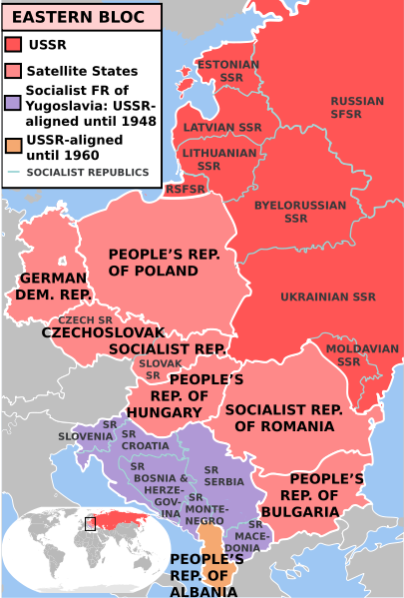During World War II (1939–45), the United States and the Soviet Union worked together as allies, as both were threatened by Hitler's increasing aggressiveness and desire for dominance. After the war, however, when both countries emerged as world powers, the alliance quickly dissolved. Stark differences between two political ideologies -- democracy and communism -- as well as desire for power preservation, made both countries more concerned with self-protection and promotion, than with mutual cooperation.

The United States used its power to try to protect existing democratic governments around the world. The Soviet Union, using the influence it had gained through the war, established and enforced communist rule and created an alliance of countries on its eastern borders that stood as a buffer between the Western world and itself -- a formation that became known as the "Eastern Bloc."

**From Allies to Satellites**

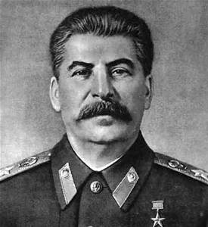In the years following the war, countries were understandably nervous about potential future military conflicts, particularly with Germany. The Soviet Union had already established alliances with countries on its western border such as Poland, Czechoslovakia, Romania, and Bulgaria -- having used its military armies to help liberate these countries from German occupation.

By the end of WWII, the Soviet Army under the leadership of Joseph Stalin (1878–1953) occupied Bulgaria, Romania, Hungary, Poland, portions of Czechoslovakia and Eastern Germany. These countries, which all came under Communist control largely due to the influence of the Soviet Union, were referred to as the Eastern Bloc. China, Yugoslavia, and Albania also adopted Communist governments in the 1940s. Although China was initially considered to be part of the Eastern bloc, it later broke with the Soviet Union.

After the war, the Soviet Union had no desire to withdraw from these occupied countries. It wanted to maintain the buffer zone as insurance against any future aggression from Germany and to uphold its military and political power in the region. It established treaties that allowed it to continue its military presence, and essentially, guaranteed its Communist political control.

**NATO and the Warsaw Pact**

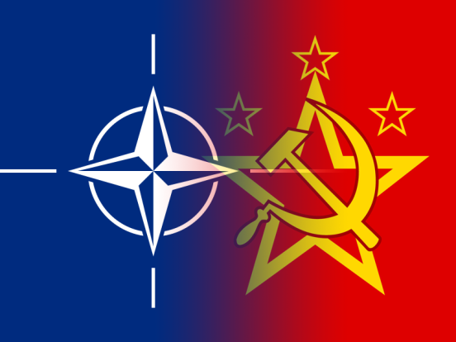The Soviet Union's confidence in its control over its allies was shaken in the late 1940s when Yugoslavia, under the leadership of Josip Broz Tito (1892–1980), gradually turned away from Stalin and began to look elsewhere for trade and economic assistance. Friction increased when Tito liquidated a faction of the Yugoslav Communist Party loyal to Moscow. In 1948, the Soviet-controlled Communist Information Bureau (Cominform), expelled Yugoslavia from its ranks and publicly denounced the country. No military action was taken, however; most believe the inaction was due to the fact that Yugoslavia did not share a border with the Soviet Union.

Meanwhile, countries like Belgium, France, the Netherlands, and the United Kingdom grew nervous about Communist expansion, and saw a need for mutual defense. They drafted the North Atlantic Treaty on April 4, 1949. The new treaty formed the North Atlantic Treaty Organization (NATO), with members including the U.S., Canada, Belgium, France, Luxembourg, the Netherlands, the United Kingdom, Denmark, Iceland, Italy, Norway and Portugal. The Soviet Union saw the formation of NATO as a direct threat, particularly when West Germany joined the group on May 9, 1955. To give structure to their alliance with the Eastern Bloc countries, and to provide an official counterweight to NATO's presence in East/West diplomacy, the Soviet Union and its Communist allies also signed a treaty on May 14, 1955, known as the Warsaw Pact. The alliance included the Soviet Union, Albania, Bulgaria, Czechoslovakia, East Germany, Hungary, Poland and Romania -- all the Communist countries of Eastern Europe except for Yugoslavia.

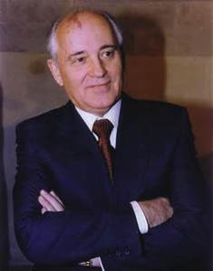**The Eastern Bloc Eventually Crumbles**

Over a span of about four decades, countries within the Eastern Bloc would try to break free, and the Soviet Union would bring them back under control either through internal pressure, martial law or, as a last resort, military invasion. After a dispute between China and the Soviet Union, Albania -- which had established ties with China -- successfully left the Bloc in the early 1960s. Romania also made moves toward independence, including establishing diplomatic ties with West Germany, and in 1968, sweeping political reforms took place in Czechoslovakia, known as the "Prague Spring."

A military invasion of Czechoslovakia restored Communist rule in 1968, and when Poland later challenged its Communist Party for power, martial law kept the Bloc intact. Eventually, when Mikhail Gorbachev (1931– ) assumed power in 1985, his policies of openness and economic restructuring allowed the countries of the Eastern Bloc to adopt reforms and eventually to establish non-Communist governments. Gorbachev made it clear that he had no interest in forcing satellite countries in Eastern Europe to comply with Soviet control.

In 1989, the Eastern Bloc was considered to have finally and completely dissolved as the last Communist regime fell in Romania; Gorbachev pulled troops out of Afghanistan; and the Berlin wall was torn down.

# Berlin Blockade / Berlin Airlift

By [Robert Wilde](http://europeanhistory.about.com/bio/Robert-Wilde-8806.htm)

### Summary:

Blockade of the US, UK and French zones of Berlin by the Soviet Union, intended to force negotiations over the division and future of Germany. It failed because the blockaded powers were able to airlift in huge amounts of supplies.

### Background:

In the final months of [World War Two](http://europeanhistory.about.com/od/worldwar2/a/ovww2.htm) Germany, the main aggressor was invaded by Allied armies: the UK, US and their allies from the west, the USSR from the East. As the war ended and peace emerged, the country was divided into four zones, occupied and administered by one of the US, UK, France and USSR. Berlin, the German capital, was deep within the Soviet zone, but was also split into four between the same nations.

### The German Question:

All the occupiers were worried about a reborn and rearmed unified Germany which would again threaten peace in Europe, but the communist Soviet Union was also worried about a unified and capitalist West Germany working closely with the US, which would first pull the Soviet zone away from Soviet control and then destabilize the communist east. The other allies wanted a unified West Germany fully integrated into pan-European economic and defense organizations to both make it self-supporting and keep it under control.

### http://upload.wikimedia.org/wikipedia/commons/thumb/a/af/Reverse_Ostmark.jpg/220px-Reverse_Ostmark.jpgThe Allies Start to Form West Germany:

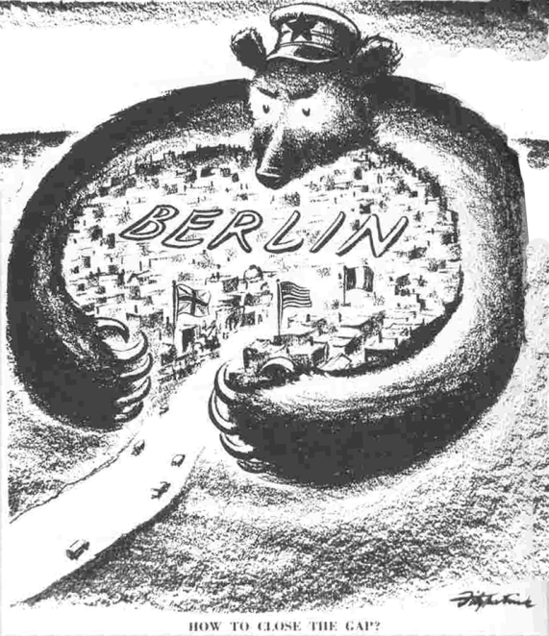Once failures in talks with the USSR had convinced the UK and US that a West German state was needed, a Six Power Conference was called between Britain, France, Belgium, Luxemburg, the Netherlands and US. It sat during the first half of 1948 and concluded successfully: on June 7th 1948 the West Germans were told to draft a constitution for a new West German state. On June 20 a new currency was introduced into the three allied zones, the Deutschmark. East Germany countered with its own new currency, the Ostmark.

### Stalin Reacts: The Berlin Blockade:

The USSR, led by [Stalin](http://europeanhistory.about.com/od/famouspeople/p/prstalin.htm), refused to accept the developments during the Six Power Conference, believing that they could apply enough pressure on the Western governments to force a renegotiation, even a neutral unified Germany. This pressure was to be applied to Berlin, in which the western zones were dependent upon supplies crossing through the larger Soviet zone in Germany. On the night of June 23-24 all rail and road links were cut off, as was the electricity supply, the excuse given being a need to stop devalued older currency flooding in from the West.

### The West Reacts:

An isolated West Berlin could not support itself for very long without supplies from outside: 2.5 million people had only five weeks food. Stalin hoped the allies would give in on West Germany to save Berlin. The initial allied reaction was surprise and confusion. Bevin, the British foreign minister, took on a forceful role, insisting that a West German state should still be created. The US and UK rejected the suggestion of General Clay, the US High Commissioner in Germany, to force an armored convoy through Soviet Germany, in case that provoked full scale war, instead favoring Bevin’s suggestion of an airlift.

### The Berlin Airlift:

In the aftermath of World War Two, three air corridors over the Soviet zone in Germany had been allocated to the allies and these, they gambled, were still open: Stalin wouldn’t risk war by shooting a plane down. There thus began a massive airlift of food, coal and other supplies between the Western German zones and Berlin. The airlift was at first highly improvised and by the end of July that year US and UK planes were bringing in 2000 tons a day.

### http://thecoldwars.files.wordpress.com/2010/12/berlin-blockade.jpgNegotiations:

2000 tons a day was good, but the Allies felt that over 5000 would be needed if West Berlin was to survive the coming winter. Worried that the airlift might fail, Allied ambassadors met with Stalin to discuss the situation. He demanded that the ostmark replace the Deutschmark in Berlin and that the future of Germany be discussed. The Allies were prepared to compromise over the currency issue, with some reservations, but not over the West German State. Feeling that the blockade would force the allies back to negotiate, the Soviets didn’t budge. The UN also tried mediating.

### The Berlin Airlift Succeeds:

In the end the Allies didn’t need to negotiate any further because the Berlin Airlift developed into a hugely successful operation, by January moving an average daily tonnage of 5620 and 8000 tons by April. A mild winter also helped, as did the introduction of larger US C54 planes and the presence of an important, possibly vital, black market with the East Germans. A thousand aircraft could be in the three air corridors at once. The airlift was totally unprecedented. The Allies also shut all exports from Germany into the Soviet zone, placing economic pressure back on the USSR.

Stalin, facing defeat, changed position, saying he’d lift the blockade if a Council of Foreign Ministers, which had met before to discuss the post war world, was held. The Allies agreed and the Blockade was lifted on May 12 1949. The Council of Foreign Ministers met eleven days later; there was to be no agreement on the fate of Germany.

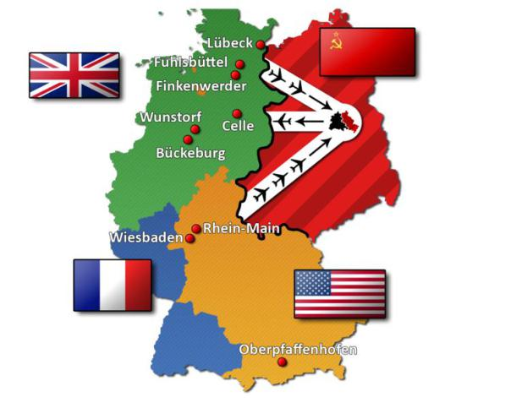Although diplomatic relations between the US led western powers and the USSR had been decaying since the end of, indeed during, the Second World War, and although the [Cold War](http://europeanhistory.about.com/od/coldwar/p/prcoldwar101.htm) was already a firm feature of the political landscape, the Berlin Blockade was the first time these former allies had been in open conflict. It also bought the threat of US nuclear power to Europe: tthe UK had asked the US to station some of its B-29 bombers on British soil, and during the Blockade sixty were sent over. The B-29 was the only plane capable of carrying and dropping an atomic bomb and, although those sent over had not been converted to carry nuclear weapons, the threat to Stalin was implicit. The Berlin Blockade has been described as "an astonishing display of the West’s industrial weight and political determination." (Walker, *The Cold War*, Vintage, 1994, p.57).

## Germany: Postwar Occupation and Division

|  |
| --- |
| On May 8, 1945, the unconditional surrender of the German armed forces (Wehrmacht) was signed by Field Marshal Wilhelm Keitel in [Berlin](http://worldfacts.us/Germany-Berlin.htm), ending World War II for Germany. The German people were suddenly confronted by a situation never before experienced in their history: the entire German territory was occupied by foreign armies, cities and infrastructure were largely reduced to rubble, the country was flooded with millions of refugees from the east, and large portions of the population were suffering from hunger and the loss of their homes. The nation-state founded by Otto von Bismarck in 1871 lay in ruins. The Establishment of Occupation Zones The total breakdown of civil administration throughout the country required immediate measures to ensure the rebuilding of civil authority. After deposing Admiral Karl Dönitz, Hitler's successor as head of state, and his government, the Allies issued a unilateral declaration on June 5, 1945, that proclaimed their supreme authority over German territory, short of annexation. The Allies would govern Germany through four occupation zones, one for each of the Four Powers--the United States, Britain, France, and the Soviet Union.    Potsdam Conference  The establishment of zones of occupation had been decided at a series of conferences. At the conference in Casablanca, held in January 1943, British prime minister Winston Churchill's proposal to invade the Balkans and East-Central Europe via Greece was rejected. This decision opened the road for Soviet occupation of eastern Germany. At the Tehran Conference in late 1943, the western border of postwar Poland and the division of Germany were among the topics discussed. As a result of the conference, a commission began to work out detailed plans for the occupation and administration of Germany after the war. At the Yalta Conference in February 1945, participants decided that in addition to United States, British, and Soviet occupation zones in Germany, the French were also to have an occupation zone, carved out of the United States and British zones.  The relative harmony that had prevailed among the United States, Britain, and the Soviet Union began to show strains at the Potsdam Conference, held from July 17 to August 2, 1945. In most instances, Soviet leader Joseph Stalin was successful in getting the settlements he desired. One of his most far-reaching victories was securing the conference's approval of his decision to compensate Poland for the loss of territory in the east to the Soviet Union by awarding it administrative control over parts of Germany. Pending the negotiation of a peace treaty with Germany, Poland was to administer the German provinces of Pomerania, Silesia, and the southern portion of East Prussia. The forcible "transfer" to the west of Germans living in these provinces was likewise approved.  The movement westward of Germans living east of a line formed by the Oder and western Neisse rivers resulted in the death or disappearance of approximately 2 million Germans, while an estimated 12 million Germans lost their homes. The presence of these millions of refugees in what remained German territory in the west was a severe hardship for the local populations and the occupation authorities.    Yalta Conference  The conferees at Potsdam also decided that each occupying power was to receive reparations in the form of goods and industrial equipment in compensation for its losses during the war. Because most German industry lay outside its zone, it was agreed that the Soviet Union was to take industrial plants from the other zones and in exchange supply them with agricultural products. The Allies, remembering the political costs of financial reparations after World War I, had decided that reparations consisting of payments in kind were less likely to imperil the peace after World War II.  The final document of the Potsdam Conference, the Potsdam Accord, also included provisions for demilitarizing and de-Nazifying Germany and for restructuring German political life on democratic principles. German economic unity was to be preserved.  The boundaries of the four occupation zones established at Yalta generally followed the borders of the former German federal states (Länder ; sing., Land ). Only Prussia constituted an exception: it was dissolved altogether, and its territory was absorbed by the remaining German Länder in northern and northwestern Germany. Prussia's former capital, Berlin, differed from the rest of Germany in that it was occupied by all four Allies--and thus had so-called Four Power status. The occupation zone of the United States consisted of the Land of Hesse, the northern half of the present-day Land of Baden-Württemberg, Bavaria, and the southern part of Greater Berlin. The British zone consisted of the Länder of Schleswig-Holstein, Lower Saxony, North Rhine-Westphalia, and the western sector of Greater Berlin. The French were apportioned the Länder of Rhineland-Palatinate, the Saarland--which later received a special status--the southern half of Baden-Württemberg, and the northern sector of Greater Berlin. The Soviet Union controlled the Länder of Mecklenburg, Brandenburg, Saxony, Saxony-Anhalt, Thuringia, and the eastern sector of Greater Berlin, which constituted almost half the total area of the city.  The zones were governed by the Allied Control Council (ACC), consisting of the four supreme commanders of the Allied Forces. The ACC's decisions were to be unanimous. If agreement could not be reached, the commanders would forego unified actions, and each would confine his attention to his own zone, where he had supreme authority. Indeed, the ACC had no executive authority of its own, but rather had to rely on the cooperation of each military governor to implement its decisions in his occupation zone. Given the immense problems involved in establishing a provisional administration, unanimity was often lacking, and occupation policies soon varied.  http://cdn.timerime.com/cdn-4/upload/resized/63062/713411/resized_image2_0b9b3f159bb85f858648493f58b6ab53.jpgThe French, for instance, vetoed the establishment of a central German administration, a decision that furthered the country's eventual division. Because they had not participated in the Potsdam Conference, the French did not feel bound to the conference's decision that the country would remain an economic unit. Instead, the French sought to extract as much as they could from Germany and even annexed the Saar area for a time.  The Soviet occupiers likewise sought to recover as much as possible from Germany as compensation for the losses their country had sustained during the war. Unlike the French, however, they sought to influence Germany as a whole and hoped to hold an expanded area of influence. In their own zone, the Soviet authorities quickly moved toward establishing a socialist society like their own.  http://www.awesomestories.com/images/user/thumb_262afb3a7f.gifThe United States had the greatest interest in denazification and in the establishment of a liberal democratic system. Early plans, such as the Morgenthau Plan to keep Germans poor by basing their economy on agriculture, were dropped as the Soviet Union came to be seen as a threat and Germany as a potential ally.  Britain had the least ambitious plans for its zone. However, British authorities soon realized that unless Germany became economically self-sufficient, British taxpayers would bear the expense of feeding its population. To facilitate German economic self-sufficiency, United States and British occupation policies soon merged, and by the beginning of 1947 their zones had been joined into one economic area--the Bizone. |

Hungarian REVOLUTION ARTICLE 1 of 2

On October 22, 1956 students, who gathered at Budapest Technical University to protest the hard-line Stalinist government, adopted a declaration which demanded three reforms of the Hungarian Government: to create a free press, to hold democratic elections, and to move the government away hard-line Stalinist policies. The Students also planned a protest for the following day; the next day, a crowd between two hundred thousand (200,000) and three hundred thousand (300,000) people gathered and demanded to hear Imre Nagy speak. Nagy was popular among the crowd because he was considerably less conservative than colleagues in the Hungarian government. Later on that night, some of the more militant factions of the crowd destroyed a statue of Joseph Stalin and tried to seize control of a local radio station from governmental forces, in the fighting that ensued twenty (20) people died.

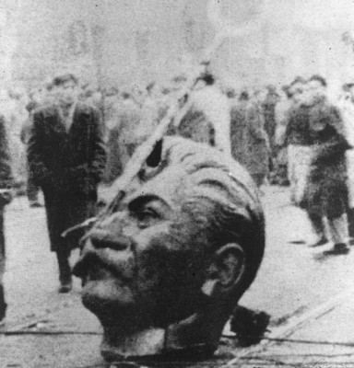On October 24th, Communist leaders within the Hungarian government gave into protester’s demands and appointed Nagy Prime Minister. As the rebellion began to spread across the country, however, those same leaders within the Hungarian government made an appeal to the Soviet Union for troops to help quell the growing rebellion. The following day, Hungarian and Soviet troops shot and killed approximately three hundred (300) people demonstrating in front of the Parliament. Soviet troops would remain in Budapest for five (5) days, withdrawing on the 29th.

The day after the Soviet troops left Budapest, rebels stormed the Budapest Communist Party headquarters in Koztarsag Square and appointed new representatives to the government. Thousands of revolutionaries also stormed the nation’s prisons to release political prisoners; the next day additional Soviet troops entered Hungary from the east. The day after Soviet forces enter the nation for the second time; Hungary withdrew from the Warsaw Pact and asked the United Nations for assistance in removing the Soviet troops from their boarders.

At dawn on November 4th, Soviet troops attacked Budapest, Kadar declared himself Prime Minister and established a new capital sixty-two (62) miles east of Budapest in the city of Szolnok, and Nagy sought refuge in the Yugoslav Embassy. Within the month Nagy was captured by the Soviet forces and transported to Romania. On December 9th, the new

Hungarian government arrested leaders of the worker’s councils; these dissidents were quickly tried in mock courts and 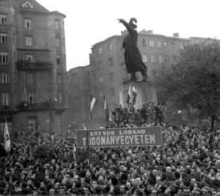executed. On June 16th, 1958 Nagy and three other officials were hung in Budapest.

# Hungarian Revolution

Article 2/2

Following the death of Josef Stalin in 1953 many European communist countries developed liberal reformist factions. In Hungary the reformist Imre Nagy became Prime Minister but his attempts at reform were thwarted by Rkosi General Secretary of the Communist party. Rkosi used every opportunity to discredit Nagy and in 1955 had him removed from office. In July 1956 Rkosi was deposed and replaced by Ernő Gerő.

In Poland a revolt staged in June 1956 had resulted in reformist concessions being granted by Russia on October 19. News of the Polish concessions encouraged Hungarians who hoped to win similar concessions for Hungary.



Imre Nagy

On the afternoon of 23rd October 1956 thousands of Hungarian students took to the streets protesting against Russian rule. Their 16 key demands included a return to power of Imre Nagy, free elections and evacuation of all Soviet troops.

By early evening the number of protestors had grown to 200,000. At 8pm Ernő Gerő made a broadcast condemning the demands as lies and stating that the country did not want to sever its ties with Russia. Angered by the broadcast some demonstrators tore down the statue of Stalin while others marched to the Radio building and attempted to gain access. The security police (VH) threw tear gas on the crowd and opened fire killing some demonstrators. In response the demonstration became violent, communist symbols were destroyed and police cars set alight.

Ernő Gerő requested Soviet military intervention and at 2am on 24th October Soviet tanks entered Budapest. However, the demonstration continued as many soldiers sympathized with the demonstrators. Imre Nagy was reinstated as Prime Minister on 24th October and called for an end to violence. However, sporadic outbursts of fighting continued until 28th October when the Russian army withdrew from Budapest.

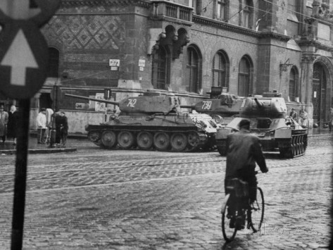The new Hungarian government immediately set about implementing its policies which included democracy, freedom of speech, and freedom of religion. Nagy also announced that Hungary would withdraw from the Warsaw Pact.

On 1st November Nagy received reports that Russian tanks had entered eastern Hungary. On 4th November the tanks reached and encircled Budapest. Nagy made a broadcast to the world that Hungary was under attack from Soviet forces hoping that maybe help would come from the West. However, at the time Britain and France were preoccupied with the Suez Crisis and Americans did not want a return to war.

Around 4000 Hungarians were killed between 4th and 10th November when the Russians took control. Nagy initially sought refuge in the Yugoslavian embassy but was later captured by the Russians. He was executed in June 1958.

23rd October is a national holiday in Hungary.

# CUBAn Revolution:

# COLD WAR COMES TO THE WESTERN HEMISPHERE

by Lisa Reynolds Wolfe

[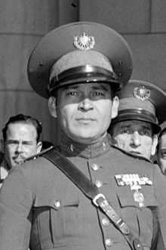](http://en.wikipedia.org/wiki/File:Batista25355a_crop4.jpg)In 1959 the United States was shaken when [Fidel Castro’s revolution](http://www.youtube.com/watch?v=NW1Yh8D-xCg) in nearby Cuba brought the Cold War to its own hemisphere. The US was directly affected economically since at this time Americans owned 50% of Cuba’s public railway system, over 90% of the telephone and power industries, the majority of key manufacturing plants, the largest chain of supermarkets, several large retail stores, and most major tourist facilities. About 25% of all Cuban bank deposits were held by branches of American banks.

Fulgencio Batista

Castro’s intent was to overthrow the oppressive dictatorship of [Fulgencio Batista](http://en.wikipedia.org/wiki/Fulgencio%20Batista) whose corrupt and inefficient regime had long been propped up through the support of the United States government.

Castro was joined in his endeavor by diverse elements — from Communists to dignitaries of the Catholic Church. These divergent social and political forces, along with some members of the business community combined to unseat Batista, thought by many to be a repressive dictator.

Even though the US had also been disillusioned with Batista’s leadership, the superpower had provided $10 million in military assistance to the Cuban government in the eight years prior to the revolution. Arms shipments were finally suspended in March 1958.

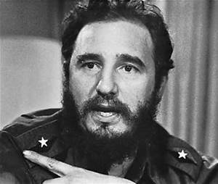Despite America’s formal position of neutrality, in actuality, the arms suspension was of great benefit to Castro’s rebels. On the other hand, the US refused to recall the military advisers who were assisting the Cuban Air Force, engaged at the time in the bombing of Cuban dissidents.

Fidel Castro

American policy managed to alienate both sides, weakening Batista’s forces at the same time that it incited Castro’s anger.

While it is impossible to know for sure what caused the lasting enmity between Castro and the American government, Cuba’s nationalization of US petroleum properties and Eisenhower’s economic sanctions — including the elimination of Cuba from the US sugar quota — lead Castro to turn to the Soviet Union for assistance.

Although the Soviet response was initially hesitant and carefully measured, the USSR soon acquiesced. One must assume that they were seduced by the opportunity to obtain a foothold only 90 miles from the Florida shores as well as by a desire to alter the strategic balance of power between the two superpowers.

Cuba, in fact, was geographically invaluable.

Moscow was soon able to establish an intelligence center for the monitoring of US missile range activities in Florida and Texas, and Cuba was also used as a tracking station for Soviet space shots.

By July 1960 the relationship was well established.

Equipment from the Soviet Union soon poured into the island nation, totaling $50 million by the end of 1960. Deliveries included MIG jet fighters, helicopters, tanks, rocket launchers, and various assault and heavy machine guns. Soviet and Czech advisers also arrived.

Castro declared himself a Marxist-Leninist in December 1961. The Soviets saw this announcement as an example of metamorphosis from a national bourgeois leader to a revolutionary democrat. Castro’s rationale may have been more pragmatic. Like Mao, he was aware that he needed to have strong superpower support to consolidate his revolution.

Meanwhile, the United States passed through the predictable phases of disenchantment with Castro, warnings about 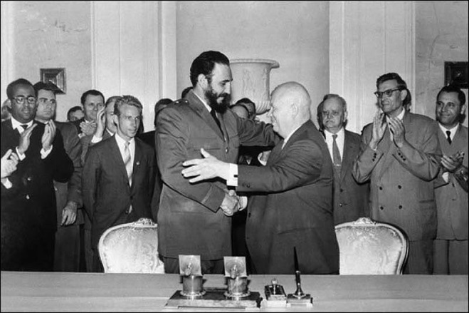him, and — finally — scheming against him. America’s diplomatic relations with Cuba were severed in January 1961.

Castro visits USSR

Many Cubans also reacted negatively. From 1959 – 1962, a steady stream of officials from the deposed Batista regime, along with other professionals and technicians opposed to the revolution, left the island.

Many of these individuals subsequently comprised the core group of 1,400 invaders who were involved in a rebellion against Castro, modeled on successful strategies of covert action employed by the US government in Iran in 1953 and Guatemala in 1954.

Masquerading as Cuban Air Force defectors, the group of exiles was organized and trained by the Central Intelligence Agency, and used American B-26 bombers to carry out their surprise air strike.

Planned during the final months of the Eisenhower administration, the operation was carried out by President Kennedy in April 1961 with invasion forces landing in the area of Cuba known as the [Bay of Pigs](http://www.youtube.com/watch?v=v-BUm312bKM) (Castro’s favorite fishing spot).

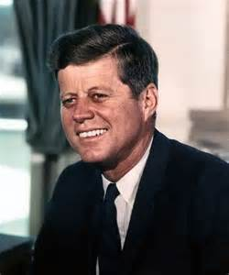The CIA expected civilian uprisings, but underestimated how much Castro’s revolution had done to help the local population. As a result, the incursion failed to incite the expected response. Instead, within three days, Castro’s army and militia had killed, captured, or thrown off the entire landing force.

President Kennedy

Reaction to the invasion was marked by a wave of anti-American demonstrations across Latin America, and the stoning of US Embassies in Tokyo, New Delhi, and Cairo. Moreover, the defeat came at the same time as a Soviet success, the first manned orbital spaceflight around the earth.

Although the United States found itself in a weakened public position, President Kennedy was bolstered by the emerging knowledge that the purported missile gap between the two superpowers was nonexistent.

Shortly after this information became public, the Soviets began sending missiles and personnel into Cuba.

# The Korean War

# “The Forgotten Conflict”

By [Kennedy Hickman](http://militaryhistory.about.com/bio/Kennedy-Hickman-27040.htm)

Fought from June 1950 to July 1953, the Korean War saw Communist North Korea invade its southern, democratic neighbor. Backed by the United Nations, with many of the troops furnished by the United States, South Korea resisted and fighting ebbed and flowed up and down the peninsula until the front stabilized just north of the 38th Parallel. A bitterly contested conflict, the Korean War saw the United States follow its policy of [containment](http://militaryhistory.about.com/od/glossaryofterms/g/Containment.htm) as it worked to block aggression and halt the spread of Communism. As such, the Korean War may be seen as one of the many proxy wars fought during the Cold War.

### Korean War: Causes

[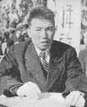](http://0.tqn.com/d/militaryhistory/1/0/X/E/-/-/korea-kim-il-sung.jpg)Liberated from Japan in 1945 during the final days of [World War II](http://militaryhistory.about.com/od/worldwarii/tp/wwii101.htm), Korea was divided by the Allies with the United States occupying the territory to the south of the 38th Parallel and the Soviet Union the land to the north. Later that year it was decided that the country would be reunited and made independent after a five-year period. This was later shortened and elections in North and South Korea were held in 1948. While the Communists under Kim Il-sung (right) took power in the north, the south became democratic. Supported by their respective sponsors, both governments wished to reunite the peninsula under their particular ideology. After several border skirmishes, North Korea invaded south on June 25, 1950, opening the conflict.

### [http://0.tqn.com/d/militaryhistory/1/6/T/E/-/-/korea-pusan-perimeter.jpg](http://0.tqn.com/d/militaryhistory/1/0/T/E/-/-/korea-pusan-perimeter.jpg)First Shots to the Yalu River: June 25, 1950-October 1950

Immediately condemning the North Korean invasion, the United Nations passed Resolution 83 which called for military assistance for South Korea. Under the UN banner, President Harry Truman ordered American forces to the peninsula. Driving south, the North Koreans overwhelmed their neighbors and forced them into a small area around the port of Pusan. While fighting raged around Pusan, UN commander [General Douglas MacArthur](http://militaryhistory.about.com/od/1900s/a/World-War-Ii-General-Douglas-Macarthur.htm) masterminded a daring [landing at Inchon](http://militaryhistory.about.com/od/battleswars1900s/p/Inchon.htm) on September 15. Along with a breakout from Pusan, this landing shattered the North Korean offensive and UN troops drove them back over the 38th Parallel. Advancing deep into North Korea, UN troops hoped to end the war by Christmas despite Chinese warnings about intervening.

### China Intervenes: October 1950-June 1951

[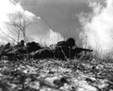](http://0.tqn.com/d/militaryhistory/1/0/U/E/-/-/korea-chosin.jpg)Though China had been warning of intervention for much of the fall, MacArthur dismissed the threats. In October Chinese forces crossed the Yalu River and entered combat. The next month, they unleashed a massive offensive which sent UN forces reeling south after engagements like the [Battle of Chosin Reservoir](http://militaryhistory.about.com/od/battleswars1900s/p/chosin.htm). Forced to retreat to the south of Seoul, MacArthur was able to stabilize the line and counterattacked in February. Re-taking Seoul in March, UN forces again pushed north. On April 11, MacArthur, who had been clashing with Truman, was relieved and replaced by [General Matthew Ridgway](http://militaryhistory.about.com/od/1900s/p/matthew-ridgway.htm). Pushing across the 38th Parallel, Ridgway repelled a Chinese offensive before halting just north of the border.

### A Stalemate Ensues: July 1951-July 27, 1953

[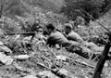](http://0.tqn.com/d/militaryhistory/1/0/V/E/-/-/korea-1951.jpg)With the UN halt north of the 38th Parallel, the war effectively became a stalemate. Armistice negotiations opened in July 1951 at Kaesong before moving to Panmunjom. These talks were hampered by POW issues as many North Korean and Chinese prisoners did not wish to return home. At the front, UN airpower continued to hammer the enemy while offensives on the ground were relatively limited. These typically saw both sides battling over hills and high ground along the front. Engagements in this period included the Battles of Heartbreak Ridge (1951), White Horse (1952), Triangle Hill (1952), and Pork Chop Hill (1953). In the air, the war saw the first major occurrences of jet vs. jet combat as aircraft dueled in areas such as "MiG Alley."

### The Korean War: Aftermath

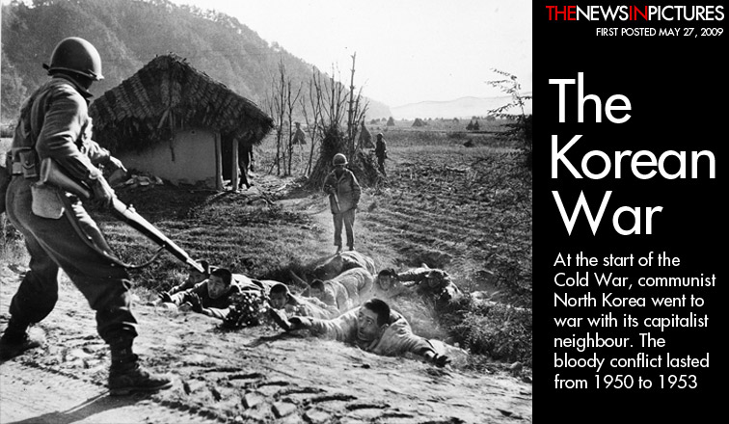The negotiations at Panmunjom finally bore fruit in 1953 and an armistice went into effect on July 27. Though fighting ended, no formal peace treaty was concluded. Instead, both sides agreed to the creation of a demilitarized zone along the front. Approximately 250 miles along and 2.5 miles wide, it remains one of the most heavily militarized borders in the world with both sides manning their respective defenses. Casualties in the fighting numbered around 778,000 for UN/South Korean forces, while North Korea and China suffered around 1.1 to 1.5 million. In the wake of the conflict, South Korea developed one of the world's strongest economies while North Korea remains an isolated pariah state.

# http://xenohistorian.faithweb.com/neasia/KoreanWar2.jpg

# Vietnam War

By [Jennifer Rosenberg](http://history1900s.about.com/bio/Jennifer-Rosenberg-7900.htm)

### What Was the Vietnam War?

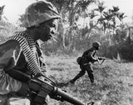The Vietnam War was the prolonged struggle between nationalist forces attempting to unify the country of Vietnam under a communist government and the United States (with the aid of the South Vietnamese) attempting to prevent the spread of communism. Engaged in a war that many viewed as having no way to win, U.S. leaders lost the American public's support for the war. Since the end of the war, the Vietnam War has become a benchmark for what *not* to do in all future U.S. foreign conflicts.

**Dates of the Vietnam War:** 1959 -- April 30, 1975

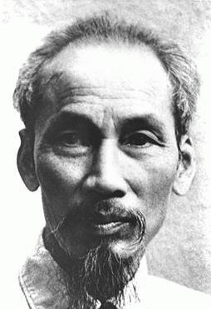**Also Known As:** American War in Vietnam, Vietnam Conflict, Second Indochina War, War Against the Americans to Save the Nation

### Ho Chi Minh Comes Home

There had been fighting in Vietnam for decades before the Vietnam War began. The Vietnamese had suffered under French colonial rule for nearly six decades when Japan invaded portions of Vietnam in 1940. It was in 1941, when Vietnam had two foreign powers occupying them, that communist Vietnamese revolutionary leader Ho Chi Minh arrived back in Vietnam after spending thirty years traveling the world.

Once Ho Chi Minh was back in Vietnam, he established a headquarters in a cave in northern Vietnam and established the Viet Minh, whose goal was to rid Vietnam of the French and Japanese occupiers. Having gained support for their cause in northern Vietnam, the Viet Minh announced the establishment of an independent Vietnam with a new government called the Democratic Republic of Vietnam on September 2, 1945. The French, however, were not willing to give up their colony so easily and fought back.

For years, Ho Chi Minh had tried to court the United States to support him against the French, including supplying the U.S. with military intelligence about the Japanese during World War II. Despite this aid, the United States was fully dedicated to their Cold War foreign policy of containment, which meant preventing the spread of Communism. This fear of the spread of Communism was heightened by the U.S. "domino theory," which stated that if one country in Southeast Asia fell to Communism then surrounding countries would also soon fall. To help prevent Vietnam from becoming a communist country, the U.S. decided to help France defeat Ho Chi Minh and his revolutionaries by sending the French military aid in 1950.

### France Steps Out, U.S. Steps In

In 1954, after suffering a decisive defeat at Dien Bien Phu, the French decided to pull out of Vietnam. At the Geneva Conference of 1954, a number of nations met to determine how the French could peacefully withdraw. The agreement that came out of the conference (called the Geneva Accords) stipulated a cease fire for the peaceful withdrawal of French forces and the temporary division of Vietnam along the 17th parallel (which split the country into communist North Vietnam and non-communist South Vietnam). In addition, a general democratic election was to be held in 1956 that would reunite the country under one government. The United States refused to agree to the election, fearing the communists might win.

With help from the United States, South Vietnam carried out the election only in South Vietnam rather than countrywide. After eliminating most of his rivals, Ngo Dinh Diem was elected. His leadership, however, proved so horrible that he was killed in 1963 during a coup supported by the United States. Since Diem had alienated many South Vietnamese during his tenure, communist sympathizers in South Vietnam established the National Liberation Front (NLF), also known as the Viet Cong, in 1960 to use guerrilla warfare against the South Vietnamese.

### First U.S. Ground Troops Sent to Vietnam

As the fighting between the Viet Cong and the South Vietnamese continued, the U.S. continued to send additional advisers to South Vietnam. When the North Vietnamese fired directly upon two U.S. ships in international waters on August 2 and 4, 1964 (known as the Gulf of Tonkin Incident), Congress responded with the Gulf of Tonkin Resolution. This resolution gave the President the authority to escalate U.S. involvement in Vietnam. President Lyndon Johnson used that authority to order the first U.S. ground troops to Vietnam in March 1965.

### Johnson's Plan for Success

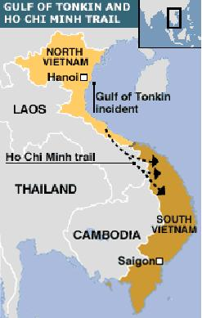President Johnson's goal for U.S. involvement in Vietnam was not for the U.S. to win the war, but for U.S. troops to bolster South Vietnam's defenses until South Vietnam could take over. By entering the Vietnam War without a goal to win, Johnson set the stage for future public and troop disappointment when the U.S. found themselves in a stalemate with the North Vietnamese and the Viet Cong.

From 1965 to 1969, the U.S. was involved in a limited war in Vietnam. Although there were aerial bombings of the North, President Johnson wanted the fighting to be limited to South Vietnam. By limiting the fighting parameters, the U.S. forces would not conduct a serious ground assault into the North to attack the communists directly nor would there be any strong effort to disrupt the Ho Chi Minh Trail (the Viet Cong's supply path that ran through Laos and Cambodia).

### Life in the Jungle

U.S. troops fought a jungle war, mostly against the well-supplied Viet Cong. The Viet Cong would attack in ambushes, set up booby traps, and escape through a complex network of underground tunnels. For U.S. forces, even just finding their enemy proved difficult. Since Viet Cong hid in the dense brush, U.S. forces would drop Agent Orange or napalm bombs which cleared an area by causing the leaves to drop off or to burn away. In every village, U.S. troops had difficulty determining which, if any, villagers were the enemy since even women and children could build booby traps or help house and feed the Viet Cong. U.S. soldiers commonly became frustrated with the fighting conditions in Vietnam. Many suffered from low morale, became angry, and some used drugs.

### http://1.bp.blogspot.com/_pPsuc9rvU4Y/TA6rrCqEjOI/AAAAAAAABrA/ecYjR6n93Kc/s1600/JumpCopters.jpgSurprise Attack

On January 30, 1968, the North Vietnamese surprised both the U.S. forces and the South Vietnamese by orchestrating a coordinated assault with the Viet Cong to attack about a hundred South Vietnamese cities and towns. Although the U.S. forces and the South Vietnamese army were able to repel the assault known as the [Tet Offensive](http://history1900s.about.com/od/1960s/qt/tetoffensive.htm), this attack proved to Americans that the enemy was stronger and better organized than they had been led to believe. The Tet Offensive was a turning point in the war because President Johnson, faced now with an unhappy American public and bad news from his military leaders in Vietnam, decided to no longer escalate the war.

### Nixon's Plan for "Peace With Honor"

In 1969, [Richard Nixon](http://history1900s.about.com/od/people/a/Nixon.htm) became the new U.S. President and he had his own plan to end U.S. involvement in Vietnam. President Nixon outlined a plan called Vietnamization, which was a process to remove U.S. troops from Vietnam while handing back the fighting to the South Vietnamese. The withdrawal of U.S. troops began in July 1969. To bring a faster end to hostilities, President Nixon also expanded the war into other countries, such as Laos and Cambodia -- a move that created thousands of protests, especially on college campuses, back in America. To work toward peace, new peace talks began in Paris on January 25, 1969.

When the U.S. had withdrawn most of its troops from Vietnam, the North Vietnamese staged another massive assault, called the Easter Offensive (also called the Spring Offensive), on March 30, 1972. North Vietnamese troops crossed over the demilitarized zone (DMZ) at the 17th parallel and invaded South Vietnam. The remaining U.S. forces and the South Vietnamese army fought back.

### The Paris Peace Accords

On January 27, 1973, the peace talks in Paris finally succeeded in producing a cease-fire agreement. The last U.S. troops left Vietnam on March 29, 1973, knowing they were leaving a weak South Vietnam who would not be able to withstand another major communist North Vietnam attack.

### Reunification of Vietnam

After the U.S. had withdrawn all its troops, the fighting continued in Vietnam. In early 1975, North Vietnam made another big push south which toppled the South Vietnamese government. South Vietnam officially surrendered to communist North Vietnam on April 30, 1975. On July 2, 1976, Vietnam was reunited as a communist country, the Socialist Republic of Vietnam.

# the Chinese Communist Revolution

By Edwin Thomas



Edwin Thomas

Edwin Thomas has been writing since 1997. His work has appeared in various online publications, including The Black Table, Proboxing-Fans and others. A travel blogger, editor and writer, Thomas has traveled from Argentina to Vietnam in pursuit of stories. He holds a Master of Arts in international affairs from American University.

The Chinese Communist Revolution was the key defining period of modern [Chinahttp://images.intellitxt.com/ast/adTypes/icon1.png](http://www.ehow.com/about_4569238_chinese-communist-revolution.html), and therefore one of the most important groupings of events of the 20th Century. By establishing a Communist regime under Mao Zedong in mainland China, and a rump Nationalist regime under Chiang Kai-Shek on Taiwan, the Revolution had ramifications that continue to define the modern world.

## Misconceptions

* + The Chinese Communist Revolution is often confused with the larger Chinese Civil War. The latter was a much larger struggle which began in 1927, and continued until at least 1950. The Chinese Communist Revolution refers specifically to the latter stages of that contest.

By some reckonings, the Chinese Civil War did not end until the Republic of China (Taiwan) unilaterally declared it over in 1991, but as the People's Republic of China never acknowledged this and there has never been a peace treaty of any kind, strictly speaking the Chinese Civil War could be considered as dormant, but not over.

## http://farm4.staticflickr.com/3310/3432116475_b0854bb660.jpgTime Frame

Kuomintang

* + The Communist Revolution began with the 1946 resumption of open war between the Communist Party of China and the Kuomintang (KMT), or Chinese Nationalists, after the end of the Second World War. It concluded with the effective victory of the Communists and the expulsion of Nationalist forces to the island of Taiwan.

## History

* + 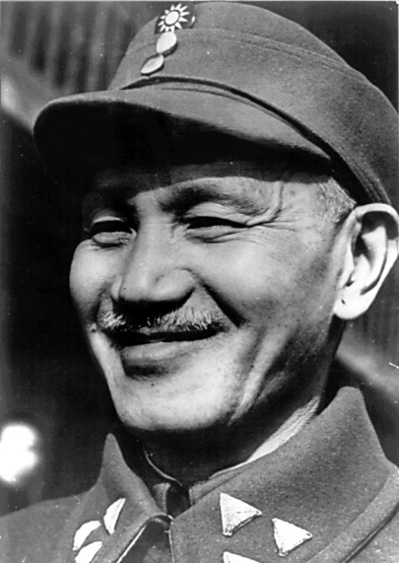With the end of the Second World War, the energies of the Communists and the KMT were no longer focused on fighting the Japanese. The 1946 breakdown of peace talks led to the resumption of hostilities, with the Soviet Union providing Mao Zedong's Communists with support, and the KMT of Chiang Kai-Shek backed by the United States.

Chian Kai-Shek

Initially the KMT sought to make the frontline of the war in Manchuria, however it was an unequal struggle. The KMT forces had borne the brunt of the conflict with the Japanese, and were largely exhausted by the effort. Contrary to later claims made by Maoists propagandists, the Communists did very little to expel the Japanese from China and were content to save their strength for a later resumption of the civil war. The Nationalists were also hamstrung by their own corruption and the failure of their economic management, which made them deeply unpopular across China.

The Communists suffered defeats and setbacks in 1946 and 1947, but learned from their errors and by 1948 had turned the tables on the KMT, defeating them in battle and capturing large amounts of demoralized troops and their equipment. Beijing fell in 1949 with hardly a shot fired in its defense. Mao Zedong formally proclaimed the People's Republic of China a reality in October 1949. Chian Kai-Shek retreated with the remainder of his [armyhttp://images.intellitxt.com/ast/adTypes/icon1.png](http://www.ehow.com/about_4569238_chinese-communist-revolution.html) and roughly two million refugees to Taiwan, and subsequently repelled from outlying islands at the Battle of Kuningtou, but the Communists captured Hainan Island in 1950. With the capture of Hainan, the lines ossified and the Chinese Communist Revolution ended.

## Effects

* + 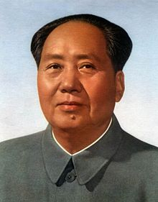For more than twenty years after the Communist Revolution, the West blocked any change in the UN [Securityhttp://images.intellitxt.com/ast/adTypes/icon1.png](http://www.ehow.com/about_4569238_chinese-communist-revolution.html) Council that would allow the Communist People's Republic of China to replace the Nationalist Republic of China as the veto-wielding permanent member. This did not change until Nixon and his famous rapprochement with the Communist Chinese.

Mao Zedong

Less than one year after the end of the Chinese Communist Revolution, Chinese troops would be battling UN forces in the Korean War. Communist victory in the world's most populous country also fanned the anti-communist hysteria of 1950s America, and the question "who lost China?" would figure prominently in the accusations of Senator Joseph McCarthy and others.

## Significance

* + The Chinese Revolution was among the first hot conflicts of the Cold War, and its ramifications were certainly among the most far-reaching. The most important long-term effect was to create a Communist state with the size and power to stand as a rival to the Soviet Union within the Communist world. The Soviets and Chinese were initially allies, but eventually split apart, and fought bloody border conflicts in the 1960s. The Sino-Soviet split forced many Communist states to choose sides, with China even invading pro-Soviet Vietnam in 1979.

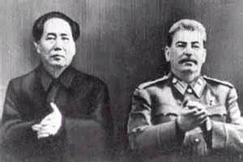 

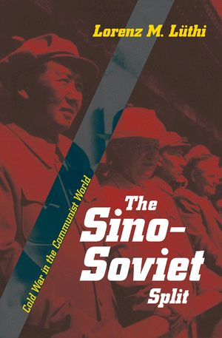





Top of Form



Add

Bottom of Form

Top of Form

Add "All Pages"Done

Bottom of Form

**Soviet War in Afghanistan**

|  |
| --- |
| Evstafiev-spetsnaz-prepare-for-mission.jpg |
| Russian Spetsnaz preparing for a mission |

The Cold War took place in between the years 1945 - 1991. People during this time had to live in constant fear of a nuclear war breaking out. Russia and America both had the resources (nuclear weapons) to destroy the whole world. In schools there would be drills for what to do if an Atom Bomb was coming. They had brochures on how to build your own bomb shelter in your basement and air raid signals in every city.**Spying on Both Sides**

During the Cold War, both Russia and America had spies in each other’s countries. Both sides were secretly getting trade secrets for their countries. The KGB for the Russian side and the CIA for the American ran the operations. Training facilities all around the country were stationed to train spies. New Technology was developed in both countries such as reconnaissance aircraft.  
  
**The Soviet War in Afghanistan**

The Soviet War in Afghanistan, also known as the "Soviet-Afghan War", was a nine year conflict involving the Soviet Union, supporting the Marxist government, against the [Islamist](http://en.wikipedia.org/wiki/Islamism) [Mujahedeen](http://en.wikipedia.org/wiki/Mujahideen#Afghanistan) Resistance

# The Soviet Invasion

On December 7, 1979, Soviet informants to the Afghan Armed Forces who were under orders from the inner circle of advisors under Soviet leader Brezhnev, relayed information for them to undergo maintenance cycles for their tanks and other crucial equipment. Meanwhile, telecommunications links to areas outside of Kabul were severed, isolating the capital. With a deteriorating security situation, large numbers of Soviet airborne forces joined stationed ground troops and began to land in Kabul on December 25. Simultaneously, Amin moved the offices of the president to the Tajbeg Palace, believing this location to be more secure from possible threats. According to Colonel General Tukharinov and Merimsky, Amin was fully informed of the military movements, having requested Soviet military assistance to northern Afghanistan on December 17. His brother and General Dmitry Chiangov met with the commander of the 40th Army before Soviet troops entered the country, to work out initial routes and locations for Soviet troops  
On December 27, 1979, 700 Soviet troops dressed in Afghan uniforms, including KGB and GRU Special Forces officers from the Alpha Group and Zenith Group, occupied major governmental, military and media buildings in Kabul, including their primary target - the Presidential Palace. In all, the initial Soviet force was around 1,800 tanks, 80,000 soldiers and 2,000 AFV'S. In the second week alone, Soviet aircraft had made a total of 4,000 flights into Kabul. With the arrival of the two later divisions, the total Soviet force rose to over 100,000

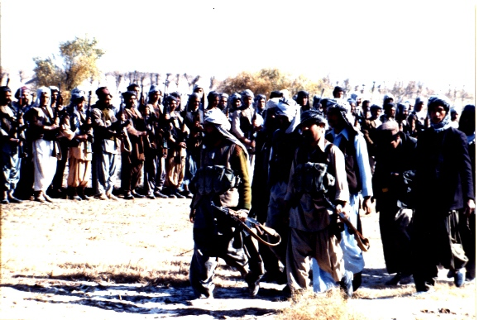

Mujahideen leader: Ismail Khan

**Mujahedeen Offensive**

The war had now developed into an entirely new pattern: The Soviets occupied the cities, and the main routes for communication; while the Mujahedeen divided into small groups, waged Guerrilla warfare. Almost 80 percent of the country escaped government control. Heavy fighting occurred in neighboring Pakistan, cities and outposts were constantly under siege by the Mujahedeen. The soviets would break these sieges up regularly, but as soon as the coast was clear, the Mujahedeen resistance would return. The cities of: Herat, and Kandahar; were partly controlled by the Mujahedeen resistance. During March 1985, the soviet General Secretary, Mikhail Gorbachev, expressed his growing impatience for the Afghan conflict. He demanded a solution be found in a one year deadline, this made 1985 one of the bloodiest years in the 10 year war. The Soviet Forces increased to 108,800 but despite suffering heavy losses the Mujahedeen were able to remain in the field and continue resisting the Soviets. The mujahedeen favored sabotage operations. The more common types of sabotage included damaging power lines, knocking out pipelines and radio stations, blowing up government office buildings, air terminals, hotels, cinemas, and so on. From 1985 through 1987, an average of over 600 "terrorist acts" a year were recorded. In the border region with Pakistan, the mujahedeen would often launch 800 rockets per day. Between April 1985 and January 1987, they carried out over 23,500 shelling attacks on government targets. The mujahedeen surveyed firing positions that they normally located near villages within the range of Soviet artillery posts, putting the villagers in danger of death from Soviet retaliation. The mujahedeen used land mines heavily. Often, they would enlist the services of the local inhabitants, even children.

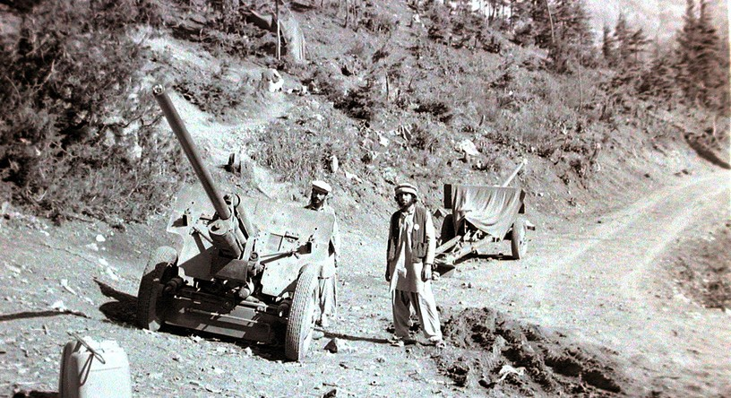

Captured Artillery Field Guns by the Rebels

**International Involvement**

In the mid-1980s, the Afghan resistance movement, assisted by the United States, Pakistan, Saudi Arabia, the United Kingdom, PRC and others, contributed to Moscow's high military costs and strained international relations. The US viewed the conflict in Afghanistan as an integral Cold War struggle, and the CIA provided assistance to anti-Soviet forces through the Pakistani intelligence Services, in a program called Operation Cyclone. A similar movement occurred in other Muslim countries, bringing contingents of so-called Afghan Arabs, foreign fighters who wished to wage Jihad against the atheist communists. Notable among them was a young Saudi named Osama Bin Laden, whose Arab group eventually evolved into Al-Queda. The Afghans were supported by a number of other countries, with the US and Saudi Arabia offering the greatest financial support. However, the Afghans were also aided by others: the UK, Egypt, China, Iran, and Pakistan. Ground support, for political reasons, was limited to regional countries. The United States began training insurgents in, and directing propaganda broadcasts into Afghanistan from Pakistan in 1978. Then, in early 1979, U.S. Foreign Service officers began meeting insurgent leaders to determine their needs. According to the then US National Security Advisor, CIA aid to the insurgents within Afghanistan was approved in July 1979, six months before the Soviet Invasion.  
**Withdrawal**

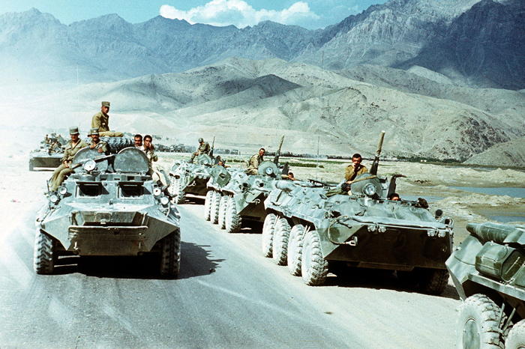

Soviet troops withdraw in APC'S and BMP'S

In the last phase, Soviet troops prepared and executed their withdrawal from Afghanistan. They hardly engaged in offensive operations at all, and were content to defend against mujahedeen raids. The one exception was Operation Magistral, a successful sweep that cleared the road between Gardez and Khost. This operation did not have any lasting effect, but it allowed the Soviets to symbolically end their presence with a victory. The withdrawal was generally executed peacefully, as the Soviets had negotiated ceasefires with local mujahedeen commanders, in order to ensure a safe passage

|  |
| --- |
|  |
|  |

# [The Czechoslovakian Uprising of 1968](http://early-cold-war-events.wikispaces.com/The+Czechoslovakian+Uprising+of+1968)

# (Prague Spring)

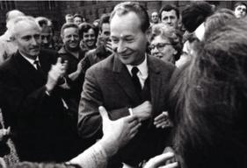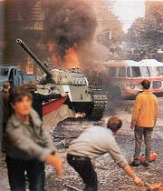The Czechoslovakian Uprising was a period of political liberalization from the reign of the Soviet Union in 1968. It began early in the year on January 5, 1968 when reformist Alexander Dubcek came into power and ended in late August when the Soviet Union and members of the [Warsaw Pact](http://en.wikipedia.org/wiki/Warsaw_Pact) invaded the country to stop the reforms that were taking place.  
  
  
 Reforms  
  
Dubcek's reforms mainly involved giving more rights to the citizens. The freedoms granted included a loosening of restrictions on the media, speech and travel. Dubček also categorized the country into two separate republics; this was the only lasting impression that Dubcek had made.  
  
These reforms were not received well by the Soviet Union. After many failed negotiations and talks, the Soviet Union sent in thousands of troops and personnel to occupy the country. This caused many violent protests in the country and Czechoslovakia remained occupied until 1990.  
  
  
  
**Important Person:** Alexander Dubcek  
  
Dubcek was conceived in Chicago and born in Czechoslovakia on November 27, 1921. He was the political leader in Czechoslovakia during Prague Spring, a reformist movement. He had many supporters from the time he gained office (January 5th, 1968) to the time of his removal when the forces of the members of the Warsaw Pact moved into the country to occupy it (August 21, 1968).  
During this time, Dubcek had a great influence on the country. In April, Dubcek launched an "Action Program" of liberalizations, which included increasing freedom of the press, freedom of speech, and freedom of movement, with economic emphasis on consumer goods and the possibility of a multiparty government.  
Unfortunately, Dubcek was removed from office when the forces had entered and controlled the country under communist regime once again. Dubcek was an influential political figure and inspired other movements throughout the world at the time of the Cold War.   
**Timeline**

* January 5, 1968- Alexander Dubchek, a Slovak with a liberal reputation, placed as First Secretary of the communist party.
* April, 1968- Action Program
* April 17, 1968- Gustav Husak replaced Dubchek as first secretary of the communist party.
* July 29, 1968- Czech and Soviet leaders met at Cierna near the border to "discuss" the situation.
* June 1968, Warsaw pact maneuvers held in Czechoslovakia.
* August 20/21, 1968- Warsaw Pact invasion. The Czech army did not resist; although there were a few isolated outbreaks of fighting.
* October 28, 1969- large protests occurred in Prague against the Soviet occupation.

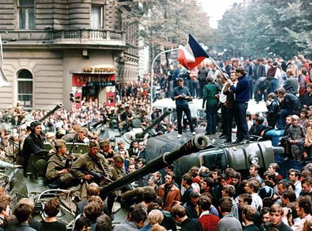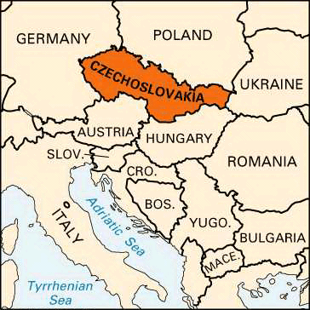  
  
**Life during "Liberation"**  
  
In Czechoslovakia, popular opposition by the general public took forms of non-violent resistance. In one case, in sheer protest, a student set himself on fire. It was hard living in such conditions as these, but eventually things calmed down by the early 1970's as Soviet Union had maintained control and occupation over Czechoslovakia (which would last until 1990).  
Many took inspirations from Prague Spring, and wrote books, songs, poetry and film. Some commented, "They may crush the flowers, but they can't stop the Spring."  
  
**Influence on the Cold War**  
After they removed Dubcek from office, and replaced the First Secretary with Husak, a period of “normalization” began. The communists tried to quickly dissolve the impressions that the Prague Spring and Dubcek had on Czechoslovakia and took the following steps:  
  
1. Consolidate Husák’s leadership and remove reformers from leadership positions;  
2. Revoke and removed laws enacted by the reform movement;  
3. Reestablish centralized control over the economy;  
4. Reinstate the power of police authorities  
5. Expand Czechoslovakia's ties with other socialist nations  
  
The uprising during 1968 had contributed to several Euro communist ideals that suggested further distance from reigning Soviet domination. A decade later, a period of Chinese political liberalization became known as the Beijing Spring. It also partly influenced the Croatian in Yugoslavia. In a 1993 Czech survey, 60% of those surveyed had a personal memory linked to the Pr

ague Spring while another 30% were familiar with the events in some other form.

The Uprising of 1968- Czechoslovakia

# Cuban Missile Crisis

At the beginning of September 1962, U-2 spy planes discovered that the [Soviet Union](http://www.spartacus.schoolnet.co.uk/RussiaSU.htm) was building surface-to-air missile (SAM) launch sites. There was also an increase in the number of Soviet ships arriving in [Cuba](http://www.spartacus.schoolnet.co.uk/2WWcuba.htm) which the United States government feared were carrying new supplies of weapons. President [John F. Kennedy](http://www.spartacus.schoolnet.co.uk/USAkennedyJ.htm) complained to the Soviet Union about these developments and warned them that the United States would not accept offensive weapons (SAMs were considered to be defensive) in Cuba.

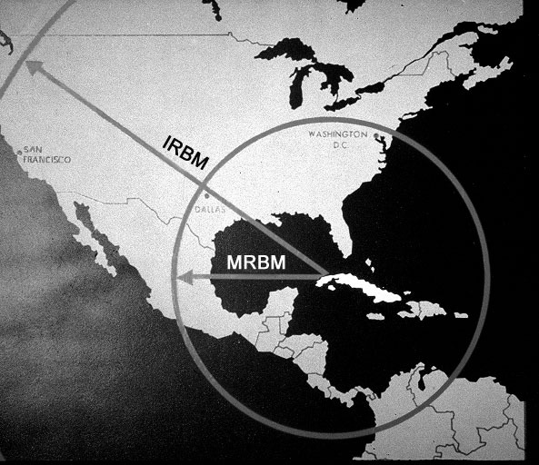As the Cubans now had SAM installations they were in a position to shoot down U-2 spy-planes. Kennedy was in a difficult situation. Elections were to take place for the United States Congress in two months’ time. The public opinion polls showed that his own ratings had fallen to their lowest point since he became president.

In his first two years of office a combination of [Republicans](http://www.spartacus.schoolnet.co.uk/USArepublican.htm) and conservative southern [Democrats](http://www.spartacus.schoolnet.co.uk/USAdemocratic.htm) in Congress had blocked much of Kennedy's proposed legislation. The polls suggested that after the elections he would have even less support in Congress. Kennedy feared that any trouble over Cuba would lose the Democratic Party even more votes, as it would remind voters of the [Bay of Pigs](http://www.spartacus.schoolnet.co.uk/COLDbayofpigs.htm) disaster where the [CIA](http://www.spartacus.schoolnet.co.uk/USAcia.htm) had tried to oust [Fidel Castro](http://www.spartacus.schoolnet.co.uk/COLDcastroF.htm) from power. One poll showed that over 62 per cent of the population was unhappy with his policies on Cuba. Understandably, the Republicans attempted to make Cuba the main issue in the campaign.

This was probably in Kennedy's mind when he decided to restrict the flights of the U-2 planes over [Cuba](http://www.spartacus.schoolnet.co.uk/2WWcuba.htm). Pilots were also told to avoid flying the whole length of the island. Kennedy hoped this would ensure that a U-2 plane would not be shot down, and would prevent Cuba becoming a major issue during the election campaign.

On 27th September, a CIA agent in Cuba overheard Castro's personal pilot tell another man in a bar that Cuba now had nuclear weapons. U-2 spy-plane photographs also showed that unusual activity was taking place at San Cristobal. However, it was not until 15th October that photographs were taken that revealed that the [Soviet Union](http://www.spartacus.schoolnet.co.uk/RussiaSU.htm) was placing long range missiles in Cuba.



Photograph of San Cristobal taken on 15th October, 1962

President Kennedy's first reaction to the information about the missiles in Cuba was to call a meeting to discuss what should be done. [Robert S McNamara](http://www.spartacus.schoolnet.co.uk/JFKmcnarmara.htm), Secretary of State for Defense, suggested the formation of the Executive Committee of the National Security Council. Fourteen men attended the meeting and included military leaders, experts on Latin America, representatives of the CIA, cabinet ministers and personal friends whose advice Kennedy valued. Over the next few days they were to meet several times. During their discussions they considered several different strategies for dealing with the crisis. They included the following:

(1) Do nothing. The United States should ignore the missiles in Cuba. The United States had military bases in 127 different countries including Cuba. The United States also had nuclear missiles in several countries close to the Soviet Union. It was therefore only right that the Soviet Union should be allowed to place missiles in Cuba.

(2) Negotiate. The United States should offer the Soviet Union a deal. In return for the Soviet Union dismantling her missiles in Cuba, the United States would withdraw her nuclear missiles from Turkey and Italy.

(3) Invasion. Send United States troops to Cuba to overthrow Castro's government. The missiles could then be put out of action and the Soviet Union could no longer use Cuba as a military base.

(4) Blockade of Cuba. Use the United States Navy to stop military equipment reaching Cuba from the Soviet Union.

(5) Bomb Missile Bases. Carry out conventional air-strikes against missiles and other military targets in Cuba.

(6) Nuclear Weapons. Use nuclear weapons against Cuba and/or the Soviet Union.

When discussing these strategies. President Kennedy and his advisers had to take into consideration how the Soviet Union and Cuba would react to decisions made by the United States.

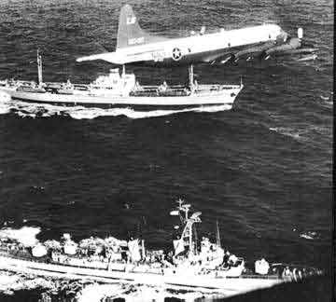At the first meeting of the Executive Committee of the National Security Council, the CIA and other military advisers explained the situation. After hearing what they had to say, the general feeling of the meeting was for an air-attack on the missile sites. Remembering the poor advice the CIA had provided before the [Bay of Pigs](http://www.spartacus.schoolnet.co.uk/COLDbayofpigs.htm) invasion, [John F. Kennedy](http://www.spartacus.schoolnet.co.uk/USAkennedyJ.htm) decided to wait and instead called for another meeting to take place that evening. By this time several of the men were having doubts about the wisdom of a bombing raid, fearing that it would lead to a nuclear war with the Soviet Union. The committee was now so divided that a firm decision could not be made.

The Executive Committee of the National Security Council argued amongst themselves for the next two days. The CIA and the military were still in favor of a bombing raid and/or an invasion. However, the majority of the committee gradually began to favor a naval blockade of Cuba.

Kennedy accepted their decision and instructed Theodore Sorensen, a member of the committee, to write a speech in which Kennedy would explain to the world why it was necessary to impose a naval blockade of Cuba.

As well as imposing a naval blockade, Kennedy also told the air-force to prepare for attacks on Cuba and the Soviet Union. The army positioned 125,000 men in Florida and was told to wait for orders to invade Cuba. If the Soviet ships carrying weapons for Cuba did not turn back or refused to be searched, a war was likely to begin. Kennedy also promised his military advisers that if one of the U-2 spy planes were fired upon he would give orders for an attack on the Cuban SAM missile sites.

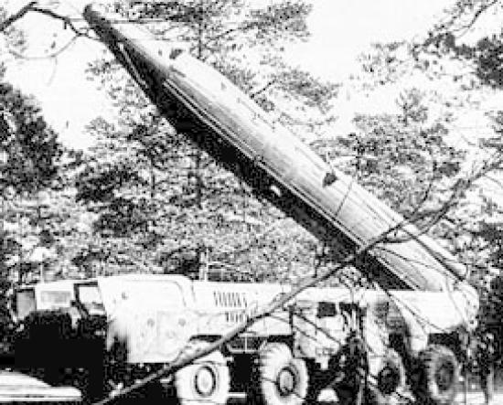The world waited anxiously. A public opinion poll in the United States revealed that three out of five people expected fighting to break out between the two sides. There were angry demonstrations outside the American Embassy in [London](http://www.spartacus.schoolnet.co.uk/ITlondon.htm) as people protested about the possibility of nuclear war. Demonstrations also took place in other cities in Europe. However, in the United States, polls suggested that the vast majority supported Kennedy's action.

On October 24, President [John F. Kennedy](http://www.spartacus.schoolnet.co.uk/USAkennedyJ.htm) was informed that Soviet ships had stopped just before they reached the United States ships blockading Cuba. That evening [Nikita Khrushchev](http://www.spartacus.schoolnet.co.uk/RUSkhrushchev.htm) sent an angry note to Kennedy accusing him of creating a crisis to help the [Democratic Party](http://www.spartacus.schoolnet.co.uk/USAdemocratic.htm) win the forthcoming election.

On October 26, Khrushchev sent Kennedy another letter. In this he proposed that the Soviet Union would be willing to remove the missiles in Cuba in exchange for a promise by the United States that they would not invade Cuba. The next day a second letter from Khrushchev arrived demanding that the United States remove their nuclear bases in Turkey.

While the president and his advisers were analyzing Khrushchev's two letters, news came through that a U-2 plane had been shot down over Cuba. The leaders of the military, reminding Kennedy of the promise he had made, argued that he should now give orders for the bombing of Cuba. Kennedy refused and instead sent a letter to Khrushchev accepting the terms of his first letter.

Khrushchev agreed and gave orders for the missiles to be dismantled. Eight days later the elections for Congress took place. The Democrats increased their majority and it was estimated that Kennedy would now have an extra twelve supporters in Congress for his policies.

The Cuban Missile Crisis was the first and only nuclear confrontation between the United States and the Soviet Union. The event appeared to frighten both sides and it marked a change in the development of the Cold War. Some of the direct consequences of the crisis include the following:

(1) The two sides established a direct communications link that became known as the Hot Line. It was hoped that this would help prevent dangerous confrontations such as the Cuban Missile Crisis arising again.

(2) Three months after the Cuban Missile Crisis the United States secretly removed all its nuclear missiles from [Turkey](http://www.spartacus.schoolnet.co.uk/2WWturkey.htm) and [Italy](http://www.spartacus.schoolnet.co.uk/2WWitaly.htm).

(3) A Test Ban Treaty was signed between the two countries in August 1963. The treaty prohibited the testing of nuclear weapons in the atmosphere.

(4) The 1,113 prisoners captured during the [Bay of Pigs](http://www.spartacus.schoolnet.co.uk/COLDbayofpigs.htm) invasion were exchanged by Castro for $60 million in food, drugs, medicine and cash.

(5) The Soviet Union became determined to have a nuclear capability that was equal to the United States. This was achieved by 1972.

(6) China accused the Soviet Union of being a 'paper-tiger' and claimed to be the true leader of the Communist movement. The split between the [Soviet Union](http://www.spartacus.schoolnet.co.uk/Russia.htm) and [China](http://www.spartacus.schoolnet.co.uk/2WWchina.htm) became wider.

(7) The United States became convinced that the Soviet Union would not go to war over another communist country. It has been argued that this encouraged the United States to help attempts to overthrow socialist and communist governments in [Vietnam](http://www.spartacus.schoolnet.co.uk/VietnamWar.htm), [Nicaragua](http://www.spartacus.schoolnet.co.uk/COLDnicaragua.htm) and [Grenada](http://www.spartacus.schoolnet.co.uk/COLDgrenada.htm).

**The Marshall Plan**

**The Need**

Europe was devastated by years of conflict during World War II. Millions of people had been killed or wounded. Industrial and residential centers in England, France, Germany, Italy, Poland, Belgium and elsewhere lay in ruins. Much of Europe was on the brink of famine as agricultural production had been disrupted by war. Transportation infrastructure was in shambles. The only major power in the world that was not significantly damaged was the United States.

**Aid to Europe**

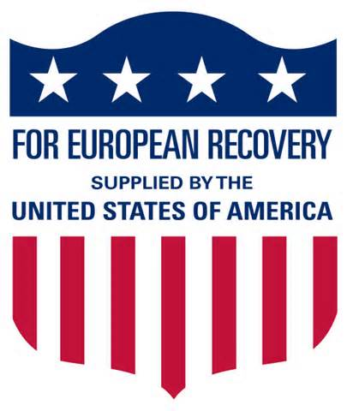From 1945 through 1947, the United States was already assisting European economic recovery with direct financial aid. Military assistance to Greece and Turkey was being given. The newly formed United Nations was providing humanitarian assistance. In January 1947, U. S. President Harry Truman appointed George Marshall, the architect of victory during WWII, to be Secretary of State. Writing in his diary on January 8, 1947, Truman said, “Marshall is the greatest man of World War II. He managed to get along with Roosevelt, the Congress, Churchill, the Navy and the Joint Chiefs of Staff and he made a grand record in China. When I asked him to [be] my special envoy to China, he merely said, ‘Yes, Mr. President I'll go.’ No argument only patriotic action. And if any man was entitled to balk and ask for a rest, he was. We'll have a real State Department now.”

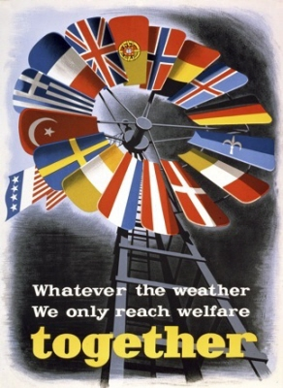In just a few months, State Department leadership under Marshall with expertise provided by George Kennan, William Clayton and others crafted the Marshall Plan concept, which George Marshall shared with the world in a speech on June 5, 1947 at Harvard. Officially known as the European Recovery Program (ERP), the Marshall Plan was intended to rebuild the economies and spirits of Western Europe, primarily. Marshall was convinced the key to restoration of political stability lay in the revitalization of national economies. Further he saw political stability in Western Europe as a key to blunting the advances of communism in that region.

**The European Recovery Program**

Sixteen nations, including Germany, became part of the program and shaped the assistance they required, state by state, with administrative and technical assistance provided through the Economic Cooperation Administration (ECA) of the United States. European nations received nearly $13 billion in aid, which initially resulted in shipments of food, staples, fuel and machinery from the United States and later resulted in investment in industrial capacity in Europe. Marshall Plan funding ended in 1951.

**Results**

Marshall Plan nations were assisted greatly in their economic recovery. From 1948 through 1952 European economies grew at an unprecedented rate. Trade relations led to the formation of the North Atlantic alliance. Economic prosperity led by coal and steel industries helped to shape what we know now as the European Union

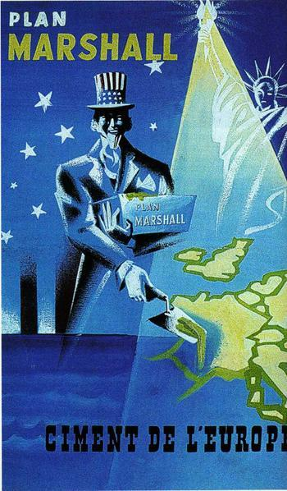 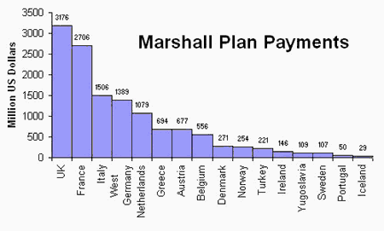

### Rise and Fall of the Berlin Wall

Shortly before midnight on Aug. 12, 1961, thousands of East German workers, guarded by troops, began to construct concrete-block and wood barriers and barbed wire fences blocking boulevards, parks, streets, and alleys in the heart of the city of Berlin, as well as the perimeter adjoining the surrounding Communist state of East Germany.

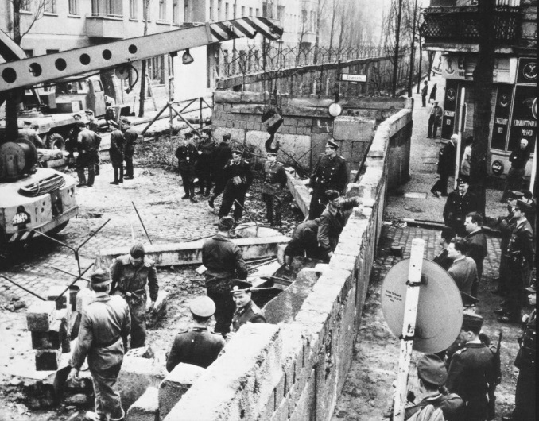By dawn on August 13, the labor gangs' work was done. Berlin had been physically divided into a western, capitalist part, connected to democratic West Germany by a handful of transit highways and air routes, and an eastern, impoverished, Communist part whose citizens were now effectively imprisoned. This "Berlin Wall" survived for 28 years, 2 months, and 26 days.

Of course, though it appeared overnight, the wall was no instant phenomenon.

At the end of World War II, defeated Germany was divided by the victors into four zones—American, British, French, and Soviet Russian. The German capital, a city of 4 million that was 105 miles inside the Russian zone, was likewise divided into four parts or "sectors."

The future of Germany, and especially of Berlin, became a bone of contention in the Cold War that followed as relations between the Western powers and their erstwhile Communist ally deteriorated.

In this contest, the Soviet dictator Joseph Stalin had one great advantage. He possessed a reserve of trusted German Communist agents. Walter Ulbricht, a dour fanatic with a goatee, was flown to Berlin within hours of its fall in May 1945 at the head of a group of these activists. His task: to take command not just of the zone but of the entire city. His cynical motto: "It must look democratic, but we must have everything in our hands."

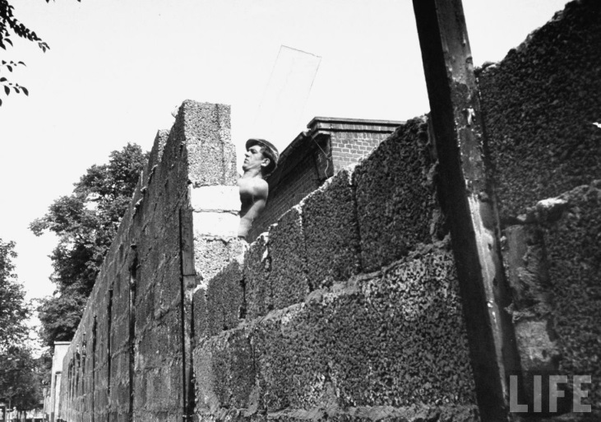Ulbricht's plans were thwarted by the Western allies and a courageous new breed of truly democratic German politicians. In June 1948, the Soviets—unable to gain control by free elections—tried to force the western sectors of Berlin into submission by closing off land access.

Led by the American military governor, Lucius D. Clay, the West defiantly mounted a massive airlift to fly supplies into their beleaguered sectors. After a year, the Russians called off the "Berlin Blockade."

Soon, Germany split into a western democratic and an eastern communist state—and Berlin definitively into East and West Berlin.

By the early 1950s, West Germany was rapidly becoming a postwar industrial powerhouse. Ulbricht's Communist domain languished economically. It began to leak skilled workers. The main border between East and West Germany was sealed. However, because of its four-power status, Berlin remained open. East Germans seeking a better life could still leave for West Berlin and, from there, fly to West Germany. Of 17 million East Germans, 2.2 million fled westward between 1949 and 1961, most via the Berlin "escape hatch."

By mid-1961, this exodus threatened the Communist state's very existence. Hence, the Berlin Wall.

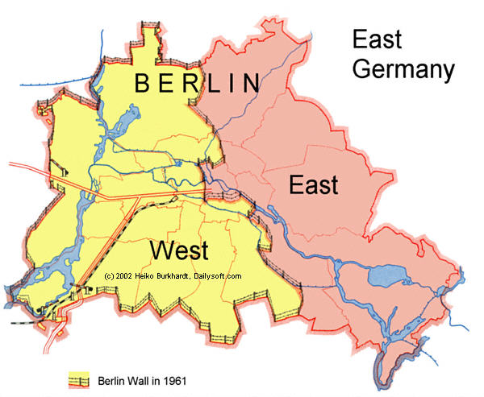Snaking for almost a hundred miles around West Berlin, the Wall became the Cold War's most potent symbol. It began 50 yards deep on the East Berlin side, with a high wall greeting potential escapers. Next came an alarmed fence, then dog-runs patrolled by vicious German shepherds. Towers stood every hundred yards, manned by guards with orders to shoot on sight. At the edge of West Berlin stood a final "marker" barrier (the part tourists wrongly assumed to be "the Berlin Wall").

Up to 250 East Germans died trying to flee. Thousands more suffered arrest and imprisonment. About 5,000 succeeded—by using false papers, by braving the fortified wall, by swimming waterways, by glider, by reinforced truck, or by digging tunnels beneath Berlin's sandy terrain.

The Berlin Wall represented a feat of Communist organization—but also brutal, undeniable proof of that system's long-term failure.

West Berlin remained an "island city" of 2 million, a democratic showcase.

East Germany, meanwhile, seemed to stabilize. Its rulers convinced themselves that their captive subjects, brainwashed by propaganda and cowed by the fearsome Stasi secret police, would resign themselves to their fate.

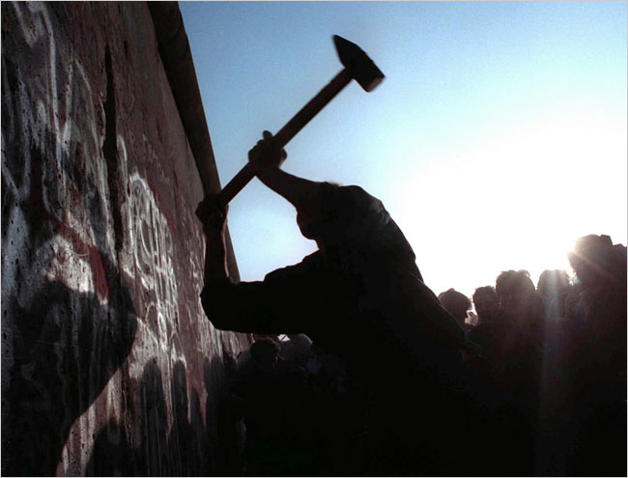They were wrong.

Short on natural resources and desperately inefficient, East Germany ran into problems during the "oil shock" of the mid-1970s. Soon it was on life support, dependent on subsidies, cheap Russian oil, and a disgusting trade in human life. Imprisoned dissidents and failed escapers were sold to the West for ever-increasing sums of hard currency. In the 1980s, this shameful business earned billions of vital West German marks.

Then came Mikhail Gorbachev, a humane, reformist Soviet leader no longer willing to rob needy Russian consumers to prop up failing satellite regimes. He decreed an end to subsidies—and to the Soviet occupation army's role as suppressor of unrest. Other Communist-ruled countries began to liberalize.

Not East Germany.

During the early months of 1989, thousands of East Germans clambered into their little Trabant cars and headed for these neighboring lands, planning to claim asylum or even cross directly to the west. At home, small, church-based demonstrations grew into huge rallies demanding freedom to travel and declaring, ominously for the rulers of a supposed "people's republic": "We are the People!"

The Communist Party tried sacking its diehard, 80-year-old boss, Erich Honecker. A new leader, Egon Krenz, known for his horsy features, vainly tried to position himself as the "East German Gorbachev." "Oh, Grandma," mocked the demonstrators' banners in the words of Red Riding Hood, "what big teeth you have!"

The East German state, demoralized and bankrupt, tried one more desperate roll of the dice. On Nov. 9, 1989, it decided to announce some relaxation of the decades-old travel restrictions, hoping to calm the situation and snatch a breathing space.

Wrong again. At a press conference, portly East Berlin Communist boss Günther Schabowski became flustered by journalists' probing questions. In response to NBC's Tom Brokaw, he wrongly stated that travel restrictions would be lifted "with immediate effect."

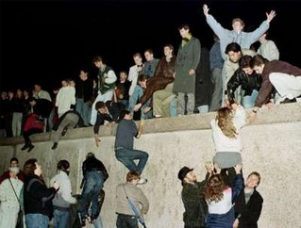Within minutes, East Berliners besieged the border posts with West Berlin. The guards, overwhelmed, phoned for instructions. Should they use force?

The leadership had no stomach for a massacre. Soon, hordes of eager East Berliners pressed past the unresisting officials into the freedom of West Berlin.

As a drinker in a bar on the eastern side remarked with dry Berlin wit: "So...they built the wall to stop people leaving, and now they're tearing it down to stop people leaving. There's logic for you."

Nineteen years ago this week, the wall had fallen overnight, just as it had risen. The city and the world celebrated into the small hours and beyond. Thousands of East Berliners wandered the glittering streets of the western districts that had been barred to them for so long.

Berlin was reunited—as Germany soon would be also—and the Cold War had come to an end.

Fall of the Soviet Union

In December of 1991, as the world watched in amazement, the Soviet Union disintegrated into fifteen separate countries. Its collapse was hailed by the west as a victory for freedom, a triumph of democracy over totalitarianism, and evidence of the superiority of capitalism over socialism. The United States rejoiced as its formidable enemy was brought to its knees, thereby ending the Cold War which had hovered over these two superpowers since the end of World War II. Indeed, the breakup of the Soviet Union transformed the entire world political situation, leading to a complete reformulation of political, economic and military alliances all over the globe.

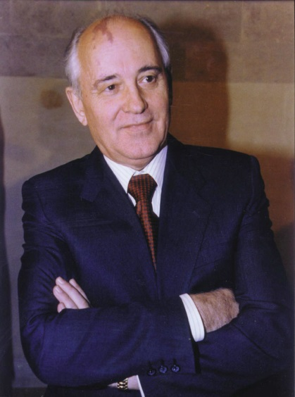What led to this monumental historical event? In fact, the answer is a very complex one, and can only be arrived at with an understanding of the peculiar composition and history of the Soviet Union. The Soviet Union was built on approximately the same territory as the Russian Empire which it succeeded. After the Bolshevik Revolution of 1917, the newly-formed government developed a philosophy of socialism with the eventual and gradual transition to Communism. The state which the Bolsheviks created was intended to overcome national differences, and rather to create one monolithic state based on a centralized economic and political system. This state, which was built on a Communist ideology, was eventually transformed into a totalitarian state, in which the Communist leadership had complete control over the country.

However, this project of creating a unified, centralized socialist state proved problematic for several reasons. First, the Soviets underestimated the degree to which the non-Russian ethnic groups in the country (which comprised more than fifty percent of the total population of the Soviet Union) would resist assimilation into a Russianized State. Second, their economic planning failed to meet the needs of the State, which was caught up in a vicious arms race with the United States. This led to gradual economic decline, eventually necessitating the need for reform. Finally, the ideology of Communism, which the Soviet Government worked to instill in the hearts and minds of its population, never took firm root, and eventually lost whatever influence it had originally carried.

Mikhail Gorbachev

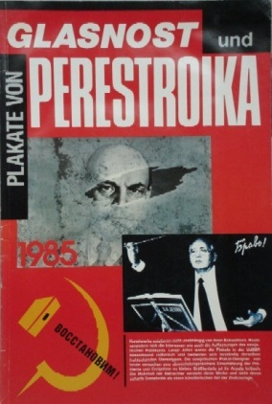By the time of the 1985 rise to power of Mikhail Gorbachev, the Soviet Union’s last leader, the country was in a situation of severe stagnation, with deep economic and political problems which sorely needed to be addressed and overcome. Recognizing this, Gorbachev introduced a two-tiered policy of reform. On one level, he initiated a policy of glasnost, or freedom of speech. On the other level, he began a program of economic reform known as perestroika, or rebuilding. What Gorbachev did not realize was that by giving people complete freedom of expression, he was unwittingly unleashing emotions and political feelings that had been pent up for decades, and which proved to be extremely powerful when brought out into the open. Moreover, his policy of economic reform did not have the immediate results he had hoped for and had publicly predicted. The Soviet people consequently used their newly allotted freedom of speech to criticize Gorbachev for his failure to improve the economy.

The disintegration of the Soviet Union began on the outside edges, in the non-Russian areas. The first region to produce mass, organized dissent was the Baltic region, where, in 1987, the government of Estonia demanded autonomy. This move was later followed by similar moves in Lithuania and Latvia, the other two Baltic republics. The nationalist movements in the Baltics constituted a strong challenge to Gorbachev’s policy of glasnost. He did not want to crack down too severely on the participants in these movements, yet at the same time, it became increasingly evident that allowing them to run their course would spell disaster for the Soviet Union, which would completely collapse if all of the periphery republics were to demand independence.

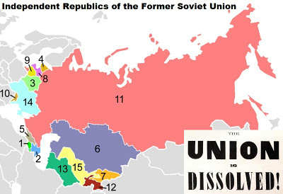After the initiative from Estonia, similar movements sprang up all over the former Soviet Union. In the Trans Caucasus region (in the South of the Soviet Union), a movement developed inside the Armenian-populated autonomous region of Nagorno-Karabagh, in the Republic of Azerbaijan. The Armenian population of this region demanded that they be granted the right to secede and join the Republic of Armenia, with whose population they were ethnically linked. Massive demonstrations were held in Armenia in solidarity with the secessionists in Nagorno-Karabagh. The Gorbachev government refused to allow the population of Nagorno-Karabagh to secede, and the situation developed into a violent territorial dispute, eventually degenerating into an all-out war which continues unabated until the present day.

Once this “Pandora’s box” had been opened, nationalist movements emerged in Georgia, Ukraine, Moldova, Byelorussia, and the Central Asian republics. The power of the Central Government was considerably weakened by these movements; they could no longer rely on the cooperation of Government figures in the republics.

Finally, the situation came to a head in August of 1991. In a last-ditch effort to save the Soviet Union, which was floundering under the impact of the political movements which had emerged since the implementation of Gorbachev’s glasnost, a group of “hard-line” Communists organized a coup d’etat. They kidnapped Gorbachev, and then, on August 19 of 1991, they announced on state television that Gorbachev was very ill and would no longer be able to govern. The country went into an uproar. Massive protests were staged in Moscow, Leningrad, and many of the other major cities of the Soviet Union. When the coup organizers tried to bring in the military to quell the protestors, the soldiers themselves rebelled, saying that they could not fire on their fellow countrymen. After three days of massive protest, the coup organizers surrendered, realizing that without the cooperation of the military, they did not have the power to overcome the power of the entire population of the country.

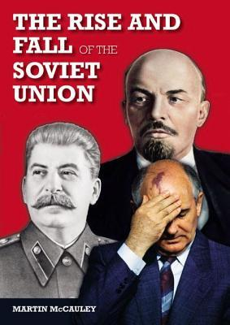After the failed coup attempt, it was only a few months until the Soviet Union completely collapsed. Both the government and the people realized that there was no way to turn back the clock; the massive demonstrations of the “August days” had demonstrated that the population would accept nothing less than democracy. Gorbachev conceded power, realizing that he could no longer contain the power of the population. On December 25, 1991, he resigned. By January of 1992, by popular demand, the Soviet Union ceased to exist. In its place, a new entity was formed. It was called the “Commonwealth of Independent Republics,” and was composed of most of the independent countries of the former Soviet Union. While the member countries had complete political independence, they were linked to other Commonwealth countries by economic, and, in some cases, military ties.

Now that the Soviet Union, with its centralized political and economic system, has ceased to exist, the fifteen newly formed independent countries which emerged in its aftermath are faced with an overwhelming task. They must develop their economies, reorganize their political systems, and, in many cases, settle bitter territorial disputes. A number of wars have developed on the peripheries of the former Soviet Union. Additionally, the entire region is suffering a period of severe economic hardship. However, despite the many hardships facing the region, bold steps are being taken toward democratization, reorganization, and rebuilding in most of the countries of the former Soviet Union.

Tiananmen Square Massacre

Bottom of Form

Bottom of Form

The Tiananmen Square Massacre was a response to a protest in the [People's Republic of China](http://www.wisegeek.com/what-is-the-peoples-republic-of-china.htm) (PRC) in 1989. Also known as the June Fourth Incident, it occurred when several waves of protests across the course of a few months came to a head. The PRC government debated over whether to try to defuse the situation through discussion, but eventually decided to suppress it militarily. Estimates of how many students were killed range from hundreds to thousands. This led to mass criticisms and sanctions around the world, and has remained a controversial topic into the 21st century.

**Background**

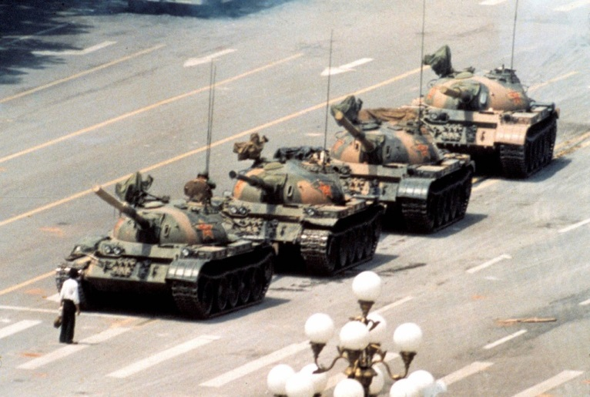The initial motivation for students coming together was the death of Hu Yaobang, who had been the General Party Secretary of the Chinese [Communist](http://www.wisegeek.com/what-is-communism.htm) Party (CCP), but was forced to resign in 1987 after several protests. Hu was considered by many to be a reformer, and many of the policies that he enacted while in office had the effect of making the government more transparent and removing some governmental control from the economy. These types of changes made him very popular with people, especially students, many of whom were very frustrated with the bureaucratic corruption and strict party control of the government.

When Hu died in April of 1989, thousands of people came to his funeral. This made some officials very uncomfortable, since he was officially disgraced when he died. The party held a public memorial shortly afterwards, which over 50,000 people attended. Upset about the way the funeral was held and at Hu's treatment by the party, some people began petitioning the Premier, Li Peng, to reverse the verdict that removed him from office in 1987 and reconsider Hu's official legacy. Others sent a list of demands that included ending restrictions on protests in Beijing, raising funding for education, ending newspaper censorship, and saying that Hu's reformist views had been correct, among other things.

**Escalation**

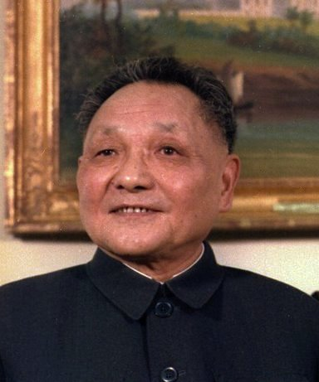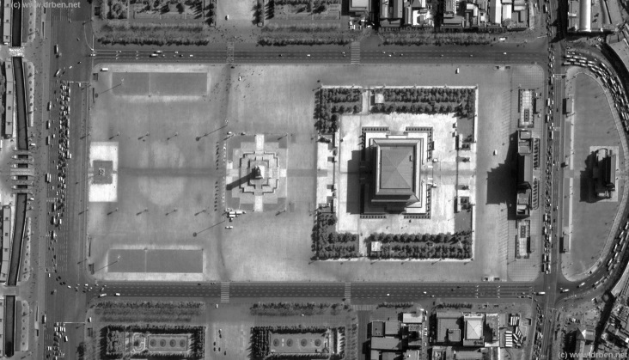As more and more mourners came to Beijing, small groups of people started clashing with police. People began to feel very upset with the government's response to Hu's death as well as their long-standing grievances, and started forming unions and committees to protest. Despite this, the majority of protesters didn't want to overthrow the government or the party, though they did want serious reforms. This started to change when an editorial was published on April 26 that advised taking a hard line with the protesters. Many more people joined the protests, and the violence began to escalate.

Deng Xiaoping

Ariel Shot of Tiananmen Square

Shortly after the editorial came out, the party's General Secretary, Zhao Ziyang, returned from a trip to North Korea. He was dismayed at the aggressive stance that the government had taken, and advised it to take a more conciliatory approach. He and Li Peng argued about it, but Li Peng convinced the overall leader of China, Deng Xiaoping, that the protests were a real threat to the security of the country and the legitimacy of the party, and that military suppression was necessary. The party began to feel more and more pressure as people continued to join the protest and students started hunger striking. When Zhao Ziyang learned that Deng had agreed to militarily suppress the protests, he declined to participate, and went to talk to the protesters, urging them to go home peacefully before the suppression started. He was subsequently purged and spent the rest of his life under house arrest until his 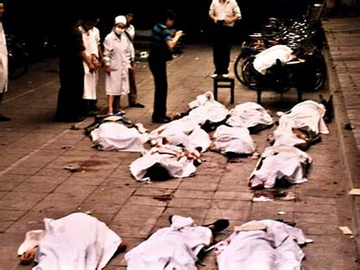death in 2005.

**Incident**

On 2 June, the party officially decided to send the People's Liberation Army (PLA) to clear Tiananmen Square, and soldiers started going into Beijing the next day. The protesters violently opposed them, with many residents of Beijing coming out into the streets to block them from getting to the square. By the time the army got to Tiananmen Square, around 1:00 AM, only a few thousand protesters were left. After they declined a final offer of amnesty, soldiers marched into the square and began firing into the crowd and beating students. The square was totally cleared by 5:40 AM.

**Aftermath**

The clearing of Tiananmen Square was criticized around the world. The US immediately put economic sanctions on China, and large-scale protests took place in Hong Kong, Shanghai, Chengdu, and other cities. Many of the people who had protested in Beijing left the country, and many countries around the world offered them visas and refugee status. Some of those who remained were arrested and sentenced to long prison terms. The Tiananmen Square Massacre remains a banned topic in China as of [2012](http://www.wisegeek.com/what-is-so-unique-about-the-year-2012.htm), and any mention of it in media, literature, or art is subject to censorship

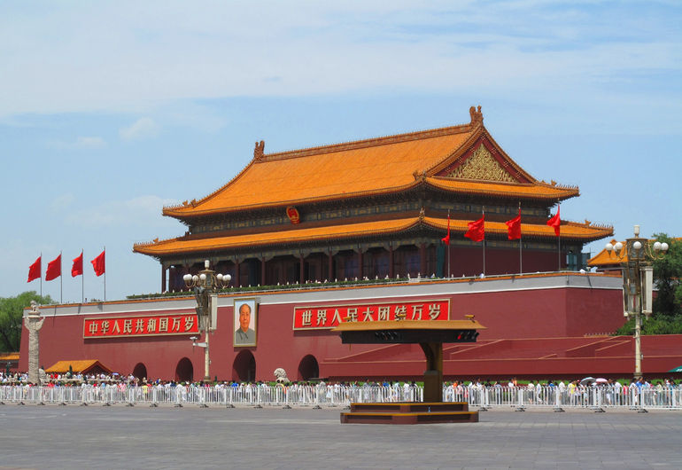

The Bay of Pigs

**On April 17, 1961, 1400 Cuban exiles launched what became a botched invasion at the Bay of Pigs on the south coast of Cuba.**

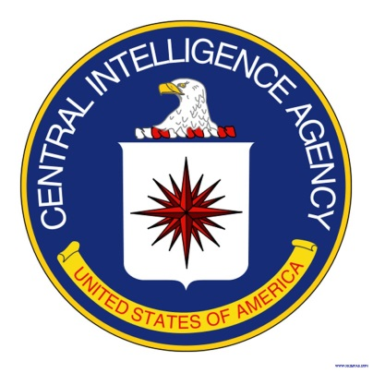In 1959, Fidel Castro came to power in an armed revolt that overthrew Cuban dictator Fulgencio Batista. The U.S. government distrusted Castro and was wary of his relationship with Nikita Khrushchev, the leader of the Soviet Union.

Before his inauguration, John F. Kennedy was briefed on a plan by the Central Intelligence Agency (CIA) developed during the Eisenhower administration to train Cuban exiles for an invasion of their homeland. The plan anticipated that the Cuban people and elements of the Cuban military would support the invasion. The ultimate goal was the overthrow of Castro and the establishment of a non-communist government friendly to the United States.

**Training**

[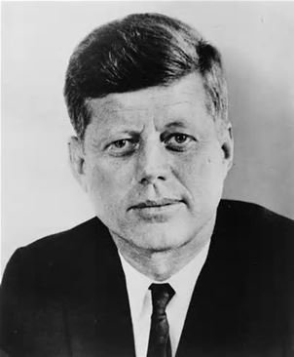](http://www.bing.com/images/search?q=kennedy&qs=n&form=QBIR&pq=kennedy&sc=0-0&sp=-1&sk=#view=detail&id=3A59D6618B4A1F23647BD4CC6E37E1487A6AA147&selectedIndex=0)President Eisenhower approved the program in March 1960. The CIA set up training camps in Guatemala, and by November the operation had trained a small army for an assault landing and guerilla warfare.

President Kennedy

José Miró Cardona led the anti-Castro Cuban exiles in the United States. A former member of Castro's government, he was the head of the Cuban Revolutionary Council, an exile committee. Cardona was poised to take over the provisional presidency of Cuba if the invasion succeeded.

Despite efforts of the government to keep the invasion plans covert, it became common knowledge among Cuban exiles in Miami. Through Cuban intelligence, Castro learned of the guerilla training camps in Guatemala as early as October 1960, and the press reported widely on events as they unfolded.

Shortly after his inauguration, in February 1961, President Kennedy authorized the invasion plan. But he was determined to disguise U.S. support. The landing point at the Bay of Pigs was part of the deception. The site was a remote swampy area on the southern coast of Cuba, where a night landing might bring a force ashore against little resistance and help to hide any U.S. involvement. Unfortunately, the landing site also left the invading force more than 80 miles from refuge in Cuba's Escambray Mountains, if anything went wrong.

**The Plan**

The original invasion plan called for two air strikes against Cuban air bases. A 1,400-man invasion force would disembark under cover of darkness and launch a surprise attack. Paratroopers dropped in advance of the invasion would disrupt transportation and repel Cuban forces. Simultaneously, a smaller force would land on the east coast of Cuba to create confusion.

The main force would advance across the island to Matanzas and set up a defensive position. The United Revolutionary Front would send leaders from South Florida and establish a provisional government. The success of the plan depended on the Cuban population joining the invaders.

**The Invasion**

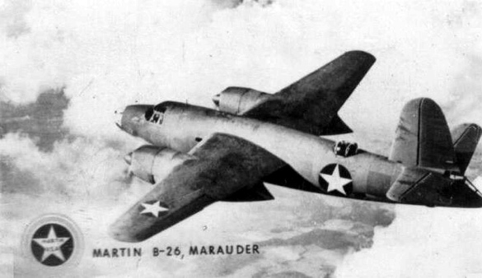The first mishap occurred on April 15, 1961, when eight bombers left Nicaragua to bomb Cuban airfields. The CIA had used obsolete World War II B-26 bombers, and painted them to look like Cuban air force planes. The bombers missed many of their targets and left most of Castro's air force intact. As news broke of the attack, photos of the repainted U.S. planes became public and revealed American support for the invasion. President Kennedy cancelled a second air strike.

On April 17, the Cuban-exile invasion force, known as Brigade 2506, landed at beaches along the Bay of Pigs and immediately came under heavy fire. Cuban planes strafed the invaders, sank two escort ships, and destroyed half of the exile's air support. Bad weather hampered the ground force, which had to work with soggy equipment and insufficient ammunition.

**The Counterattack**

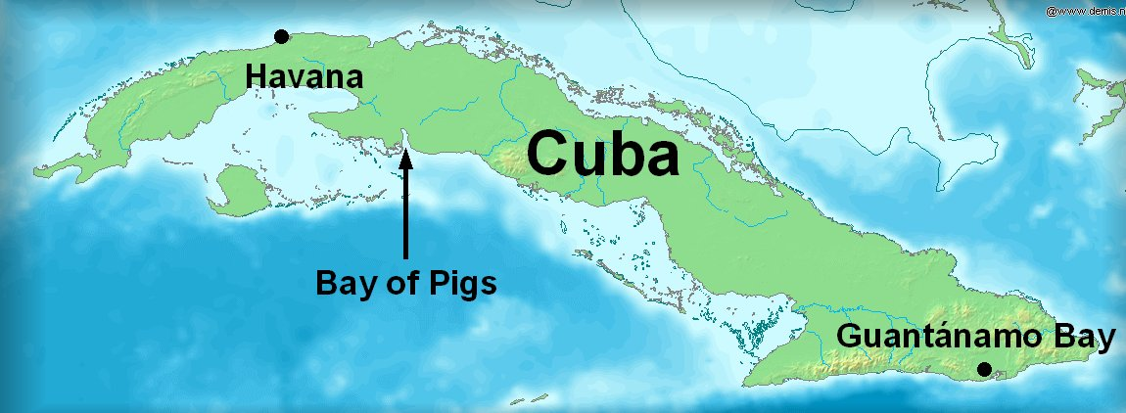Over the next 24 hours, Castro ordered roughly 20,000 troops to advance toward the beach, and the Cuban air force continued to control the skies. As the situation grew increasingly grim, President Kennedy authorized an "air-umbrella" at dawn on April 19—six unmarked American fighter planes took off to help defend the brigade's B-26 aircraft flying. But the B-26s arrived an hour late, most likely confused by the change in time zones between Nicaragua and Cuba. They were shot down by the Cubans, and the invasion was crushed later that day.

Some exiles escaped to the sea, while the rest were killed or rounded up and imprisoned by Castro's forces. Almost 1,200 members of Brigade 2056 surrendered, and more than 100 were killed.

**The Aftermath**

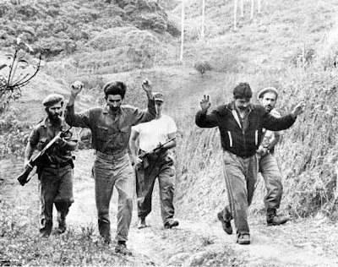The brigade prisoners remained in captivity for 20 months, as the United States negotiated a deal with Fidel Castro. Attorney General Robert F. Kennedy made personal pleas for contributions from pharmaceutical companies and baby food manufacturers, and Castro eventually settled on $53 million worth of baby food and medicine in exchange for the prisoners.

On December 23, 1962, just two months after the end of the Cuban Missile Crisis, a plane containing the first group of freed prisoners landed in the United States. A week later, on Saturday, December 29, surviving brigade members gathered for a ceremony in Miami's Orange Bowl, where the brigade's flag was handed over to President Kennedy. "I can assure you," the president promised, "that this flag will be returned to this brigade in a free Havana."

The disaster at the Bay of Pigs had a lasting impact on the Kennedy administration. Determined to make up for the failed invasion, the administration initiated Operation Mongoose—a plan to sabotage and destabilize the Cuban government and economy. The plan included the possibility of assassinating Castro. Almost 50 years later, relations between Castro's Cuba and the United States remain strained and tenuous.

Greek Civil War Article 1 of 2

President Harry S. Truman addressing a joint session of Congress asking for $400 million in aid to Greece and Turkey. This speech became known as the "Truman Doctrine". After the evacuation of German forces from Greece in 1944, there were two groups in that country that wanted to take power: the monarchists and the Communists. A civil war soon developed. The Communists were supported by the Soviet Union, and, after the end of the Second World War, also by Yugoslavia, Albania and Bulgaria. Britain and the United States supported the monarchists. The involvement of the United States in the Greek civil war marked a new era in their attitude towards world politics. The new approach became known as the “Truman Doctrine” and it would guide U.S. diplomacy for the next forty years. The doctrine was established on 12 March 1947, when President Harry S. Truman delivered a speech before Congress in which he called for the allocation of $400 million in military and economic assistance for Greece and Turkey. In his speech, Truman declared: It must be the policy of the United States to support free peoples who are resisting attempted subjugation by armed minorities or by outside pressures.

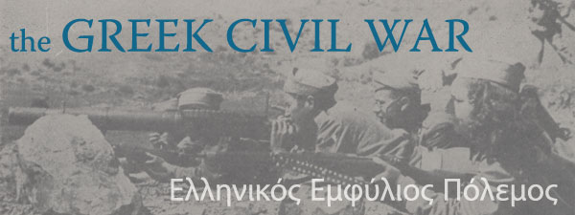

## The Greek Civil War article 2 of 2

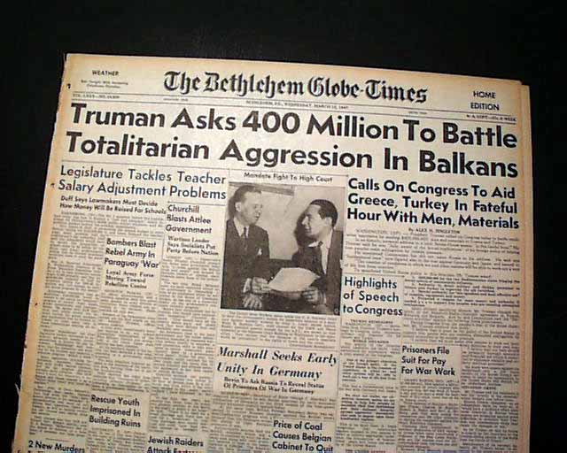With this political instability in Greece during the early twentieth century, General Ioannis Metaxas took power with a fascist-style dictatorship. Once Metaxas died in 1941, Greece was left powerless and the Communist Party took control and created the National Liberation Front, also called the EAM. Another group was formed that was against the EAM called the National Republican Greek League (EDES). The EAM and EDES fought each other in the winter of 1943-1944. The EDES received help from the British since Britain was worried about a communist takeover. Winston Churchill met with Joseph Stalin in 1944. Churchill agreed to give Stalin power in Romania if Stalin gave Churchill power in Greece. The Germans, still there from World War II, began to withdraw from Greece because of this and Stalin gave no help to the communists, even though they were the powerful group in Greece. On December 2, 1944, fighting started between the British and the EAM. The nationalists won and the size of the Communist party greatly decreased.

In March of 1946, elections were held in Greece. The elections were corrupt and as a result, the victory was greatly in favor of the EDES. Therefore, the Communists formed the Democratic Army of Greece (DA), declaring they were fighting to restore Greece to a democracy. During the first year of fighting, the DA was ahead since they were receiving help from Yugoslavia and controlled the northern part of Greece. The British became increasingly worried and turned to the United States for help. In 1947, the United States agreed to help so President Truman issued the Truman Doctrine to help Greece fight the Communists.

By the time the US entered, the DA was holding land at the boarders of Yugoslavia and Albania, as well as land in southern Greece. The DA used guerrilla tactics for their warfare whereas the nationalists were receiving weapons from the United States and Britain. Once the United States went to Greece, the nationalist army greatly increased. Then, Stalin ended his relationship with Yugoslavia’s leader, Tito. The DA decided to support Stalin and lost the support of Yugoslavia. With this factor, and the help from the Americans, the nationalists were able to defeat the communists by the summer of 1949. During the course of the war, more than 80,000 people were killed while another 700,000 were left homeless. The civil war left Greece in shambles. However, in the 1950’s, Greece went through a growth of development, both socially and economically. From 1960 until 1974, Greece was ruled by Georgios Papandreou. Finally in 1974, Greece was restored as a democracy by Konstantinos Karamanlis.

The Solidarity movement in Poland   
Established in September of 1980 at the [Gdansk shipyards](http://www.local-life.com/gdansk/articles/gdansk-shipyard), Solidarity was an independent labor union instrumental in the eventual collapse of the Soviet Union, and the primary catalyst that would transform Poland from a repressive communist satellite to the EU member democracy it is today. The Solidarity movement received international attention, spreading anti-communist ideas and inspiring political action throughout the rest of the Communist Bloc, and its influence in the eventual fall of communism in Central and Eastern Europe cannot be understated or dismissed.

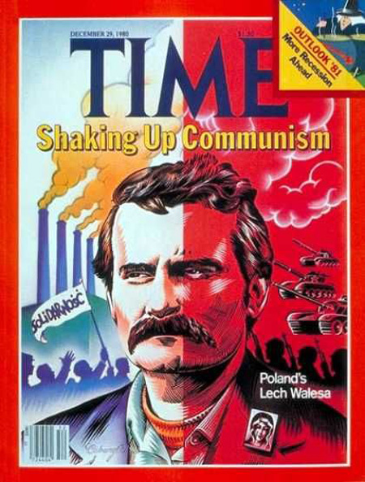Solidarity's cohesion and initial success, like that of other dissident movements, was not created overnight, nor the result of any specific event or grievance. Rather, the emergence of Solidarity as a political force in Poland was spurred by governmental and economic difficulties that had continued to deepen over the course of an entire decade. Poland's 'shortage economy' put stress on the lives of everyday people who were unable to purchase daily necessities, such as bread or toilet paper, and faced endless queues for which there was rarely a reward. In July of 1980, the Polish government - facing economic crisis - was again forced to raise the price of goods while curbing the growth of wages. This was essentially the "last straw" for much of Poland's labor force, with strikes spreading almost at once across the country, in spite of the absence of any organized network.

In Gdansk, at the then 'Lenin Shipyards', the shipyard workers were unified by the additional outrage of Anna Walentynowicz's firing. The dismissal of Walentynowicz - a popular crane-operator and activist, combined with the previous firing of Lech Walesa - an outspoken electrician, galvanized the workers into taking action. A strike began on August 14th, led by Walesa, who gave voice to the workers' demands for the legalization of independent labor unions, the raising of a monument to the 80 workers brutally murdered in a 1970 labor dispute in Gdansk, and the rehiring of both Walesa and Walentynowicz. Despite nation-wide censorship and the severance of all phone connections between Gdansk and the rest of the country, several underground presses succeeded in covering the story and spreading the shipyard workers' message throughout Poland and the Eastern Bloc. On August 16th, several other strike committees joined the Gdansk shipyard workers and the following day 21 demands of the unified strike committee were put forward. These demands went far beyond the scope of local concern, calling for the legal formation of independent trade unions, an end to media censorship, the right to strike, new rights for the Church, the freeing of political prisoners, and improvements in the national health system. The movement's news-sheet, Solidarnosc, began being printed on the shipyard printing press at a run of 30,000 copies.

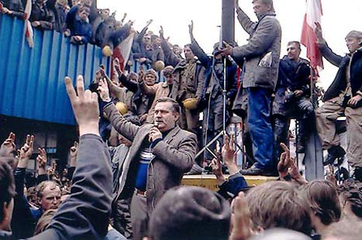On August 18th, the Szczecin shipyard joined the Gdansk shipyard in protest, igniting a wave of strikes along the Polish coast. Within days, most of Poland was affected by factory shutdowns, with more and more unions forming and joining the Gdansk-based federation on a daily basis. With the situation in Gdansk gaining international support and media coverage, the Gdansk shipyard workers were able to hold out longer than many of their compatriots. Poland's Soviet government capitulated, sending a Governmental Commission to Gdansk, which on September 3rd signed an agreement ratifying many of the workers' demands. This agreement, known as the Gdansk Agreement, became recognized as the first step in dismantling Soviet power. Achieving the right to form labor unions independent of Communist Party control, and the right to strike, workers' concerns would now receive representation; common people were now able to introduce democratic changes into the communist political structure.

With an upsurge of momentum in the wake of their success, workers' representatives - with Walesa on the pulpit - formed a national labor union on September 17th and Solidarity ('Solidarnosc' in Polish) was born. The first independent labor union in the Soviet Bloc, Solidarity's existence was remarkable to people the world over who had previously thought such an organization could never exist under communism. In Poland, millions of people hopeful for change rallied around the union and in the 500 days following the Gdansk Agreement, 10 million people - students, workers, intellectuals - joined Solidarnosc or one of its sub-organizations (Independent Student Union, Craftsmen's Union, Farmer's Union, etc.). A quarter of the country's population bravely became members, including 80% of Poland's workforce, marking the only time in human history that such a percentage of a country's population voluntarily joined an organization. With the country behind them, Solidarity slowly transformed from a trade union to a full-on revolutionary movement, using strikes and other acts of protest to force change in government policies. The movement was careful, however, never to use violence, for fear of encouraging and validating harsh reprimands from the government.

As quickly as December 1980, the [Monument to Fallen Shipyard Workers](http://www.local-life.com/gdansk/culture/409-Monument_to_Fallen_Shipyard_Workers) was erected, and the following month Walesa and other Solidarity delegates met with [Pope John Paul II](http://www.local-life.com/krakow/articles/pope-john-paul-krakow) in Rome. After 27 Solidarity members in Bydgoszcz were assaulted by the state police during a state-initiated National Council meeting on March 19th, news spread throughout the underground press and nation-wide strike was planned. This action, involving over half a million people, brought Poland to a standstill and was the largest strike in the history of the Eastern Bloc. The government was forced to promise an investigation into the Bydgoszcz beatings and allow the story to be released to the international press.

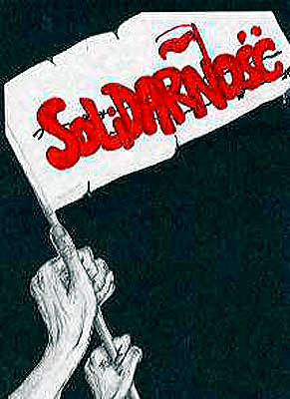After the Gdansk Agreement, [Moscow](http://www.local-life.com/moscow/) stepped up pressure on its Polish government, which continued to lose its control over Polish society. The Soviets put General Wojciech Jaruzelski in the driver's seat, expecting a crackdown on the Solidarity movement. On December 13th, 1981, Juruzelski delivered, declaring martial law and arresting some 5,000 Solidarity members in the middle of the night, Walesa and other Gdansk leaders among them. Censorship was expanded and police filled the streets. Hundreds of strikes taking place throughout the country were put down harshly by riot police, including several deaths during demonstrations in Gdansk and at the Wujek Coal Mine. By the end of 1981 strikes had ceased and Solidarity seemed crippled. In October of 1982, Solidarity was delegalized and banned. The Polish people were bowed, but not broken....

Solidarity Symbol

Upon the arrest of the Solidarity leadership, more underground structures began to form, including Solidarity Radio and over 500 underground publications. Solidarity managed to persevere throughout the mid-80s as an underground movement, garnering extensive international support which condemned Jaruzelski's actions. No other movement in the world was supported by such a wide gamut: Reagan, Thatcher, the Pope, Carrillo (head of communist Spain); NATO, Christians, Western communists, liberals, conservatives, and socialists - all voiced support for Solidarity's cause. US President Ronald Reagan imposed sanctions on Poland, which would eventually force the government to soften its policies. The CIA and Catholic Church provided funds, equipment and training to the Solidarity underground. And the Polish people still supported what remained of the movement, demonstrating through masses held by priests such as Jerzy Popieluszko, who would himself later become a martyr of the cause.

By November of 1982, Walesa was released from prison; however, less than a month later, the government carried out an attack upon the movement, arresting 10,000 activists. On July 22, 1983, martial law was lifted, yet many restrictions on civil liberties and political life remained, as well as food rationing which would continue until the late 80s. On October 5th, Lech Walesa was awarded the Nobel Peace Prize, despite the Polish government's attempts to defame him and their refusal to allow him to leave the country and accept the award.

[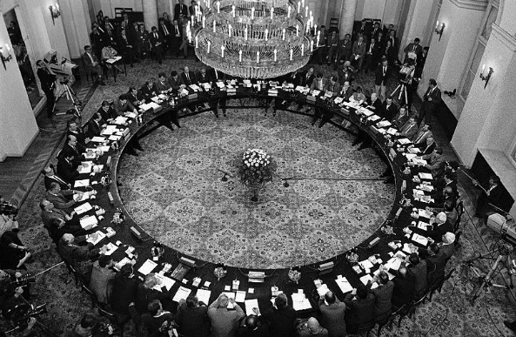](http://upload.wikimedia.org/wikipedia/commons/a/a2/Okragly_Stol_1989.jpg)When Mikhail Gorbachev assumed control over the Soviet Union in 1985, he was forced to initiate a series of reforms due to the worsening economic situation across the entire Eastern Bloc. These reforms included political and social reforms which led to a shift in policy in many Soviet satellites, including Poland, and led to the happy release of hundreds of political prisoners connected with Solidarity. However, Solidarity members continued to be the objects of persecution and discrimination. By 1988, Poland's economic situation was worse than ever due to foreign sanctions and the government's refusal to introduce more reforms. A new wave of strikes swept the country after food costs were increased by 40%. Finally on August 26, the government announced it was ready to negotiate with Solidarity and met with Walesa, who incredulously agreed to call an end to the strikes. In preparation for an official negotiating conference with the government, a hundred-member committee was formed within Solidarity, composed of many sections, each of which was responsible for presenting specific demands to the government at the forthcoming talks. This conference, which took place in [Warsaw](http://www.local-life.com/warsaw/) from February 6th to April 4th, 1989, came to be known as the 'Polish Roundtable Talks.' Though the members of Solidarity had no expectation of major changes, the Roundtable Talks would irreversibly alter the political landscape and Polish society.

On April 17, 1989, Solidarity was again legalized and the party was allowed to field candidates in upcoming elections. With its members immediately jumping to 1.5 million after legalization, the party was restricted to fielding candidates for only 35% of the seats in the new Sejm. Despite aggression and propaganda from the ruling party, extremely limited resources and pre-election polls that promised a communist victory, Solidarity managed to push forward a campaign that surprised everyone, including themselves. The party won every contested seat in the Sejm and 99 of 100 Senatorial seats: the new 'Contract Sejm' as it was called would be dominated by Solidarity. As agreed beforehand, Wojciech Jaruzelski was elected president; however the communist candidate for prime minister now failed to rally enough support to form a government and the Sejm elected Solidarity representative Tadeusz Mazowiecki as Prime Minister of Poland. Mazowiecki became the first non-communist prime minister in Poland since 1945 and the first anywhere in Eastern Europe for 40 years. Under Mazowiecki a Solidarity-led government was formed, and only Jaruzelski remained of the old regime. Communism had collapsed in Poland and within months the famous [Wall in Berlin](http://www.berlin-life.com/berlin/wall) would do the same.

Polish Roundtable Talks

The fall of communism in Poland thrust Solidarity into a role it was never prepared for, and in its life as a political party it saw much infighting and a decline in popularity. Walesa decided to resign from his Solidarity post and announced his intent to run for president in the upcoming elections. In December 1990, Lech Walesa was elected president of Poland and became the first Polish president ever elected by popular vote. The 1990 elections in Poland, which scored astonishing victories for anti-communist candidates, set-off a string of peaceful anti-communist revolutions throughout Central and Eastern Europe which led to the fall of communism is these regions. In the Baltics people were joining hands in solidarity, and the cry for freedom could be heard in the [Estonian Singing Revolution](http://www.local-life.com/tallinn/articles/estonian-singing-revolution) and its Lithuanian and Latvian counterparts. The example of Solidarity had emboldened the oppressed peoples of the entire Eastern Bloc to stand together and demand their independence. By Christmas of 1991, the USSR had ceased to exist, and all the former communist territories across Eurasia became sovereign entities once again.

Mapping The Cold War

1. Using the articles provided as a start, write a summary of the events including all of the following in the boxes on the map:

* Cause(s) of the event
* What the event was
* Date(s) of the event
* Key individuals/groups involved
* Whether or not it was connected to the Containment Theory   
   (contain communism in Russia and China)
* Was it a victory for Capitalism or Communism?
* Whether or not it was a nuclear weapons issue

1. Events to research:

|  |  |
| --- | --- |
| Overview of the Cold War (not mapped) | Vietnam War |
| Formation of the Soviet Bloc | Bay of Pigs Invasion |
| Marshall Plan | Building of the Berlin Wall |
| Chinese Revolution | Cuban Missile Crisis |
| Berlin Blockade & Airlift | Prague Spring |
| Korean War | Tiananmen Square Massacre |
| Truman Gets Involved in Greek Civil War | Soviet Invasion of Afghanistan |
| Cuban Revolution | Solidarity Movement |
| Fall of the Berlin Wall | Hungarian Revolution |
| Fall of the USSR | Division of Germany |
|  |  |