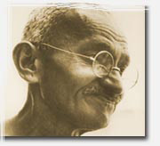

**INDIA - DEFYING THE CROWN**

By March 1930 the people of India are growing more restless under the yoke of British rule. Indian nationalists turn to Gandhi to lead a campaign for full independence. Having successfully employed nonviolent sanctions while fighting for suppressed Indians in South Africa, and then again in India in the 1920s, Gandhi moves to confront the colonial rulers in ways that average Indians can understand and be part of.

His first target is the British monopoly on the manufacture and sale of salt, and he leads a 250-mile march to the sea, where he and thousands of protestors violate the law by making their own salt. The British crack down, and many, including Gandhi, go to jail.

But civil disobedience spreads, and the campaign encompasses a boycott of British cloth and the resignations of local Indian officials who work for the British. All this puts great pressure on the government, and the British viceroy opens talks with Gandhi, who opts for compromise. Although the campaign does not dislodge the British from India, it shatters the legitimacy of British control and rallies the Indian people to the cause of independence, which eventually comes in 1947.

**India Overview**

With a campaign to win rights for Indians in South Africa behind him, Mohandas Gandhi returns to his native India in 1915 to find a country growing increasingly restless under the century-long colonial British rule called the "raj." While the British do not resort to the brutality used by most occupying forces, they limit basic liberties wherever the power of the raj is threatened. And, although Britain has granted self-rule to Canada and Australia, it drags its heels on self-rule for India. British viceroy Lord Irwin ignores most of the demands of the Indian National Congress.

By 1930, Gandhi decides that the time is right for civil disobedience directed at the heart of British interests. Recognizing the need for a unifying issue that speaks to all Indians, he finds one in the colony's Salt Act, which forbids citizens from collecting or selling the vital mineral. The colonizers, he argues, are stealing a dietary staple from the people and then making them pay to get it back. By processing their own salt, millions of Indians can readily flout British rule.

In a shrewd preemptive move, Gandhi sends a public letter to Lord Irwin announcing his intent to break the British salt monopoly at the conclusion of a long people's march to the sea where ordinary citizens will collect salt. At the same time, he implores Indian local officials to resign their posts, to drive a wedge between the raj and one of its key supports. He further advocates a boycott of imported British cloth in favor of homespun cotton — a strategy that is of added significance for Indians who have been thrown out of work by Britain's machine-manufactured textile industry.

These actions invite brutal reprisals. A mass of demonstrators approaching a salt depot in Dharasana is viciously beaten; thousands are arrested, the number of participants swells, and resistance stiffens. Overcrowding the country's jails is part of Gandhi's strategy to put a strain on British civil services, and the barbarism at Dharasana elicits worldwide support for the Indian cause. With India's infrastructure under strain, and world opinion turning against the Crown, Lord Irwin agrees to one-on-one negotiations with Gandhi in February 1931. While the social and legal concessions that he grants (i.e., withdrawal of repressive laws and promises not to prosecute resisters) are more symbolic than concrete, the great Indian resistance of 1930-31 mobilizes the nation as never before to pursue independence, which it finally achieves in 1947.

**India Timeline**

**1906**  
Gandhi leads nonviolent campaign against anti-Indian laws in South Africa.

**1915**  
Gandhi returns to India from South Africa.

**1920**  
Gandhi leads first of his all-India campaigns against the British Empire.

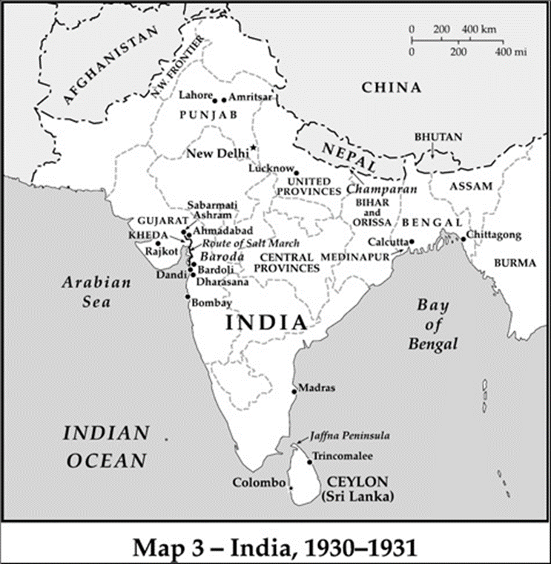**March 12, 1930**  
Gandhi and his followers begin salt march, which launches the civil disobedience campaign for independence.

**April 6, 1930**  
Marchers arrive at coast and make salt; civil disobedience begins to spread across India.

**May 4, 1930**  
Gandhi is arrested.

**January 1931**  
Gandhi and other Indian leaders are released from prison.

**February 17, 1931**  
Gandhi-Irwin talks begin, resulting in "truce" and suspension of civil disobedience.

**January 1, 1932**  
Civil disobedience resumes.

**August 1947**  
India gains independence from British Empire.

**India People**

**MOHANDAS GANDHI**was the spiritual and practical founder of nonviolent resistance, a concept he called *satyagraha*, meaning “steadfastness in truth.” Born into India’s caste of grocers and moneylenders, Gandhi studied law in England and practiced in South Africa, where his outrage about discrimination against the Indian community led to his development of *satyagraha*. Upon his return to India, he soon became the dominant figure in the Indian National Congress, the political party that stove for independence from the British. Gandhi went on to direct India’s struggle for independence for nearly 30 years, steering an ever-escalating course of “noncooperation” that led to mass demonstrations, strikes, the boycott of British goods, and his frequent imprisonment. The Salt March of 1930, during which Gandhi encouraged Indians to protest salt taxes, was the turning point in the movement. Gandhi also fought to improve the status of India’s casteless “untouchables” and was tireless in his efforts to forge closer bonds among his nation’s numerous religious factions. He was, ironically, assassinated in 1948 by a Hindu fanatic.

Born in 1879, **SAROJINI NAIDU** was educated in India at Madras University (entering at age twelve) and later, in England at both King's College and Girton College. An avid spokeswoman for Mahatma Gandhi's non-cooperation movement, Sarojini traveled to both Africa and North America in support of the rights of Indians. Like Gandhi, she was imprisoned numerous times by the British authorities in India because of her activism. Sarojini, described as "the Nightingale of India," was also a prominent literary figure in Bombay. She has left behind a legacy of published poems, currently collected under the titles *The Sceptered Flute* (1928) and *The Feather of the Dawn* (1961).

The son of affluent parents, **JAWAHARLAL NEHRU** was born in Allahabad, India in 1889. After completing his studies at Cambridge, he became a lawyer and served in the Allahabad High Court.

Nehru met Gandhi in 1916 at the annual convention of the Indian National Congress. For over twenty years, he worked with Gandhi to free India from British rule, political activity for which he was imprisoned nine times.

By 1929, Nehru had been elected president of the Indian National Congress. In 1947, when India finally gained independence from England, Nehru became India's first Prime Minister and Minister of External Affairs.

During the Cold War, Nehru followed a policy of neutrality. Domestically, he introduced a policy of industrialization, reorganized the states on a linguistic basis, and brought the dispute with Pakistan over Kashmir to a peaceful solution. Nehru died in 1964.

**Gandhi and Satyagraha**

For Gandhi, who saw all life as arising from a unity of being, there was no division between spiritual and practical activity, and he tried to live that way. One spiritual principle that had practical value for him was that of *ahimsa* or (loosely translated) "nonviolence". If no individual or group could claim absolute knowledge of the truth, no one should use violence to compel others to act against their different but also sincere understanding of it. *Ahimsa* had deep roots within Buddhist, and Hindu thinking, but Gandhi also found vigorous expressions of the same precept in Christian thought, especially in the Sermon on the Mount and in the writings of Leo Tolstoy. He read Tolstoy's book, *The Kingdom of God Is Within You*, in 1894 and found himself "overwhelmed" by the Russian's argument against violence.

*Ahimsa* had clear implications for political conflict. Violence used against oppression, Gandhi believed, was not only wrong, it was a mistake. It could never really end injustice, because it inflamed the prejudice and fear that fed oppression. For Gandhi, unjust means would never produce a just outcome. "The means may be likened to a seed, the end to a tree," he wrote in 1909, "and there is just the same inviolable connection between the means and the end as there is between the seed and the tree. . . We reap exactly as we sow."

Yet Gandhi had to find methods of political action that would also be effectual. In South Africa his early actions as an Indian leader had been nonviolent, but speeches, petitions, letters, and meetings with officials had barely dented racist attitudes and laws. What he sought, and found, was a way to compel whites to see the truth that Indians would have to be treated as equals.

At first he called it "passive resistance" (a term he disavowed in later years). The technique was simple: Declare opposition to an unjust law (such as restrictions on free movement), break the law (by crossing a border illegally), and suffer the consequences (arrest, physical abuse, prison). Resisters' calm and dignified suffering, Gandhi believed, would open the eyes of oppressors and weaken the hostility behind repression; rather than adversaries being bullied to capitulate, they would be obliged to see what was right, and that would make them change their minds and actions. Gandhi named this concept of action *satyagraha* (combining the Hindu words for "truth" and "holding firmly.")

But *satyagraha* soon took on a larger dimension, one that was less a function of its spiritual provenance than its feasibility. Gandhi recognized that there were limits to the exemplary value of personal sacrifice: even the most committed resisters could absorb only so much suffering, and the pride and prejudices typical of entrenched regimes could not be dissolved quickly. If *satyagraha* was to become a practical political tool, Gandhi realized, it had to bring pressure to bear on its opponents. "I do not believe in making appeals," he wrote, "when there is no force behind them, whether moral or material."

The potential of *satyagraha* to change an opponent's position, Gandhi believed, came from the dependence of rulers on the cooperation of those who had the choice to obey or resist. While he continued to argue that *satyagraha* could reveal the truth to opponents and win them over, he often spoke of it in military terms and planned actions that were intended not so much to convert adversaries but to jeopardize their interests if they did not yield. In this way he made *satyagraha* a realistic alternative for those more interested in what could produce change than in what conscience could justify.

**India Analysis**

The great 1930-1931 campaign against the British in India did not produce constitutional change, but it demonstrated that ordinary Indians had the power to drive events. In several parts of India nationalists succeeded in weakening the structures that undergirded the raj. Tax resistance, product boycotts, and resignations stretched the twin sinews of government – money and personnel. On a few occasions – in Peshawar at the end of April, in parts of Gujarat for most of 1930 – civil disobedience showed the British what it would be like if they could no longer take for granted the reliability of Indians who staffed colonial government and law enforcement. And the British could not be certain that brush fires that started in these areas would not jump to other parts of the subcontinent. The costs of containing the campaign were high enough to move the viceroy to negotiate an end to the conflict, on terms that failed to satisfy all his colleagues.

Yet beneath the surface, the raj never faced a general crisis of governability. Nationalists did not undermine the loyalty of police forces, and repression, although often clumsy and always costly, was never foiled effectively. The campaign had been designed to deflect any single shattering blow – local activists hardly missed a beat when all-India leaders were arrested, and there were too many people involved, spread out over too much territory, for the authorities to stamp out all opposition. But beatings, imprisonment, land attachments, and other measures wore down resistance in many places. And whatever strategic adjustments Gandhi's movement might have made to neutralize repression would not have altered the fact that there were large communities of Indians that did not join the campaign. Without solidarity from Muslims and industrial workers, civil disobedience by Gandhi's followers could accomplish only so much.

While the campaign did not wreck the raj, it did succeed in shredding the legitimacy of British rule. For over a century the regime had represented itself as benign, standing for sound economy and gradual reform – and likely to bring home rule in the long run. As long as Indians went about their business and cooperated with its laws and institutions, the British could maintain this façade. But civil disobedience shattered it.

Time after time and in place after place, Indians disobeyed laws they saw as unjust, and their rulers beat them, jailed them, took their property, banned their publications, and outlawed their organizations. On the streets of Lucknow, at the salt works in Dharasana, in the villages of Gujarat, the regime demonstrated in broad daylight that colonial rule was a form of domination. The British were happy to have the consent of Indians wherever possible, but, in the absence of consent, they would rule by the club and the gun. Civil disobedience exposed this truth, and it resounded through British and Indian relations in years to come.

Nothing reveals the loss of authority suffered by the raj better than the change in what it meant for Indians to go to jail. Once a mark of shame, a term in prison became a badge of pride. Narayan Desai recalled shouting in delight, when he was a boy, "This time no less than two years!" as his father (Gandhi's secretary) was hauled off to prison in the back of a police van. Imprisonment still worked as a means of physical coercion, but it no longer carried any stigma in the eyes of most Indians.

The campaign's leaders were out to do more than destroy the prestige of the raj; they also tried to become the one force that could speak in the name of the people. In this sense nonviolent mass action was a bid to seize political primacy from the British by offering overwhelming evidence that, while the British still ruled Indians, Gandhi and his colleagues in the Congress party led them. Congress declared and suspended the campaign, and Congress leaders and volunteers undertook the most well-publicized acts of civil disobedience and suffered the most visible brutalities.

But their position was never unchallenged, for reasons that had less to do with the British than with Indians. Congress saw itself as guiding the masses for disciplined nonviolent action, but its national and provincial leaders often ended up authorizing actions they did not inaugurate and could not control. Congress all too often found itself following rather than leading, restraining rather than mobilizing. Moreover, the failure to bring Muslims and Sikhs into the struggle meant that Congress did not speak for all India, foreshadowing the later division of India as well as bitter communal strife that far outlasted the British.

Yet the experience of civil disobedience transformed the people who went through it. Just a generation earlier a zealous sense of Indian nationhood was limited to a small number of mainly educated, urban Hindus, and allegiance to religious communities, castes, and linguistic groups overshadowed citizenship. But after Indians at all levels of society had joined together in collective nonviolent action against forms of injustice that touched them all, a new civil spirit was operating in India that was independent of British will.

The salt campaign gave people a joint calling and forged durable links among Indians from different classes and regions. The Bombay merchants who lost their shirts by sticking to the cloth boycott, the university students in Lahore who were thrown in jail for picketing, and the Congress volunteers who were battered at Dharasana - all these Indians now shared with each other, and with revered leaders like Gandhi and the Nehrus, a common history: They had put aside their personal interests to promote the nation's interest in evicting the British. India was no longer just a patchwork on a map – it was a fluent idea in the public mind.

The simple act of standing up to the authorities dispelled the sense of inferiority that colonial rule both fostered and required. Usha Mehta recalled how proud the old women in her family were to participate in the salt satyagraha. Her great-aunts and grandmothers would bring home salt water, boil it down, and "then they would shout at the top of their voices: 'We have broken the salt law.'" The campaign also changed the way their overlords were seen: The British were no longer invincible. Their viceroy had negotiated with Mohandas Gandhi, recognizing, if only fleetingly, a man whose authority derived solely from his ability to articulate his people's longings. The British, until they sat down with Gandhi, "were all sahibs and we were obeying them," said Narayan Desai. "No more after that."

Gandhi's personal role in the civil disobedience campaign was towering. For millions of Indians he was the embodiment of national purpose. Inside Congress his stature gave him enormous leverage, which he used to keep quarreling factions together and to spur the party to turn itself into a mass political organization. Gandhi's ideas about satyagraha and swaraj (self-rule), moreover, galvanized the thinking of Congress cadres, most of whom by 1930 were committed to pursuing independence by nonviolent action.

That the civil disobedience campaign flowed from Gandhi's leadership does not, however, mean that it was a simple projection of his ideals. The dynamic of satyagraha, as Gandhi originally conceived it, started with breaking the laws of the raj, then forcing the British to punish protestors. Their suffering would touch the hearts of the oppressors, expose the injustice of their rule, and create conditions in which the British would choose to leave. Naively, Gandhi even believed that Irwin's willingness to negotiate indicated a personal change of heart. But Gandhi and Irwin were not the same as India and Britain: Irwin was impressed by Gandhi, but his government was not ready to regard the Indian people as sovereign.

Apart from Irwin, the British naïveté was to see Gandhi as a kind of tribal witch doctor, whipping up the unwashed masses; Churchill had called him a "fakir." But for all his appearance as a saintly and unworldly figure, Gandhi understood the realpolitik of Indian liberation. He knew that civil disobedience had to strain imperial control sufficiently that the game for the British would not be worth the candle. And his "truth force" was adaptable to this very worldly goal: Most of his followers took part in nonviolent action not in order to seek some sort of moral transfiguration but to overcome their adversaries – by denying them the cooperation and revenue that made it possible to hold India. Demonstrating to the British that they were wrong was ultimately beside the point; the goal was to force the British out.

Nonviolent action did not force out the British in 1930-31, and it did not work the way that Gandhi had expected – but it worked. The suffering of protestors did not change the minds of the British, but it did change the minds of Indians about the British. For tens of millions of Indians, satyagraha and its result changed cooperation with the raj from a blessing into blasphemy. The old order, in which British control rested comfortably on Indian acquiescence, had been sundered. In the midst of civil disobedience, Sir Charles Innes, a provincial governor, circulated his analysis of events to his colleagues. "England can hold India only by consent," he conceded. "We can't rule it by the sword."

The British lost that consent, and had civil disobedience been more disciplined, had Congress separated the raj from its means of coercion, and above all, had India been united, they might have lost their empire's brightest jewel long before they did.